AFRIKAANS F.A.L
WORKBOOK 3

06 – 10 AUGUST 2020

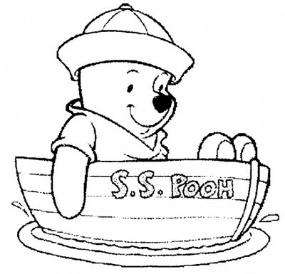

AFRIKAANS F.A.L
GRADE 4
WEEK OF 03 – 07 AUGUST
LOCKDOWN 2020

DAG 1  MAANDAG | - Hi dearest grade 4 learner. We really miss you at school. We hope that you are doing well and still working hard to learn new things in this time.  - This week we start off with a bit of revision work. We are practising our phonetic sounds and word building.  - Look at the first three worksheets and do what you are instructed to do. Try and work without the use of a dictionary where possible.  - Good luck and work hard this week.
DAG 2  DINSDAG | - Today we are going to focus on our comprehension skills.  - You have two very short stories to read. One is about a spider and the other is about a friendly cow.  - Read through them and make sure you understand the content of the work.  - Now answer each set of questions in Afrikaans. Please write in full sentences at all times.  - Find the answers in the passages.
DAG 3  WOENSDAG | - Today we are doing language work. We learn about “antonieme” and learn a few examples of each.  - These words are the opposite meaning of each other. For example: sleep / awake, wet / dry.  - Make sure you know the Afrikaans name and spelling of this language learning.  - Now you need to do the activity. Fit the opposite meaning given to you,next to the word given. After you have done that, go and find the words in the crossword puzzle.
DAG 4
DONDERDAG

DAG 5
VRYDAG

DATUM:
WOORDBOU (WORD BUILDING)

1. Gebruik die vokaalklanke (phonetic sounds) gegeeom die woordvirelkeprentteskryf.
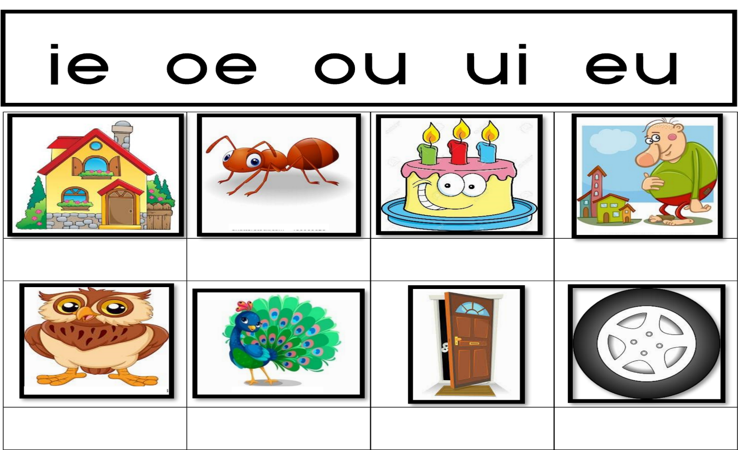
Use the phonetic sounds given to write down the word for each picture.

2. Kiesnou die regtewoorduit die raamgegeeenvoltooi die sinne.
(Choose the correct word given in the list and complete the sentences.)

ouma | tier | muis | hoed | kleur | fout | tuin | dier

1. Die ____________________________eetelkeaandkaas.

2. ___________________________ bakaltydvironslekkerkoek.

3. Ek het ‘n __________________________in my toetsgemaak.

4. Pappa spit in die _________________________ omblommete plant.

5. Die meisie __________________________ die prentjiemooi in.

6. Daar was ‘n groot ____________________________ by die dieretuin.

7. In die somermoetek ‘n ____________________ draom my tebeskerm.

8. ‘n Beer is ‘n baiegroot, bruin _____________________.

3. Kyk nou of jy woorde kan vorm met die volgende klanke.
(Build words with the sounds given)
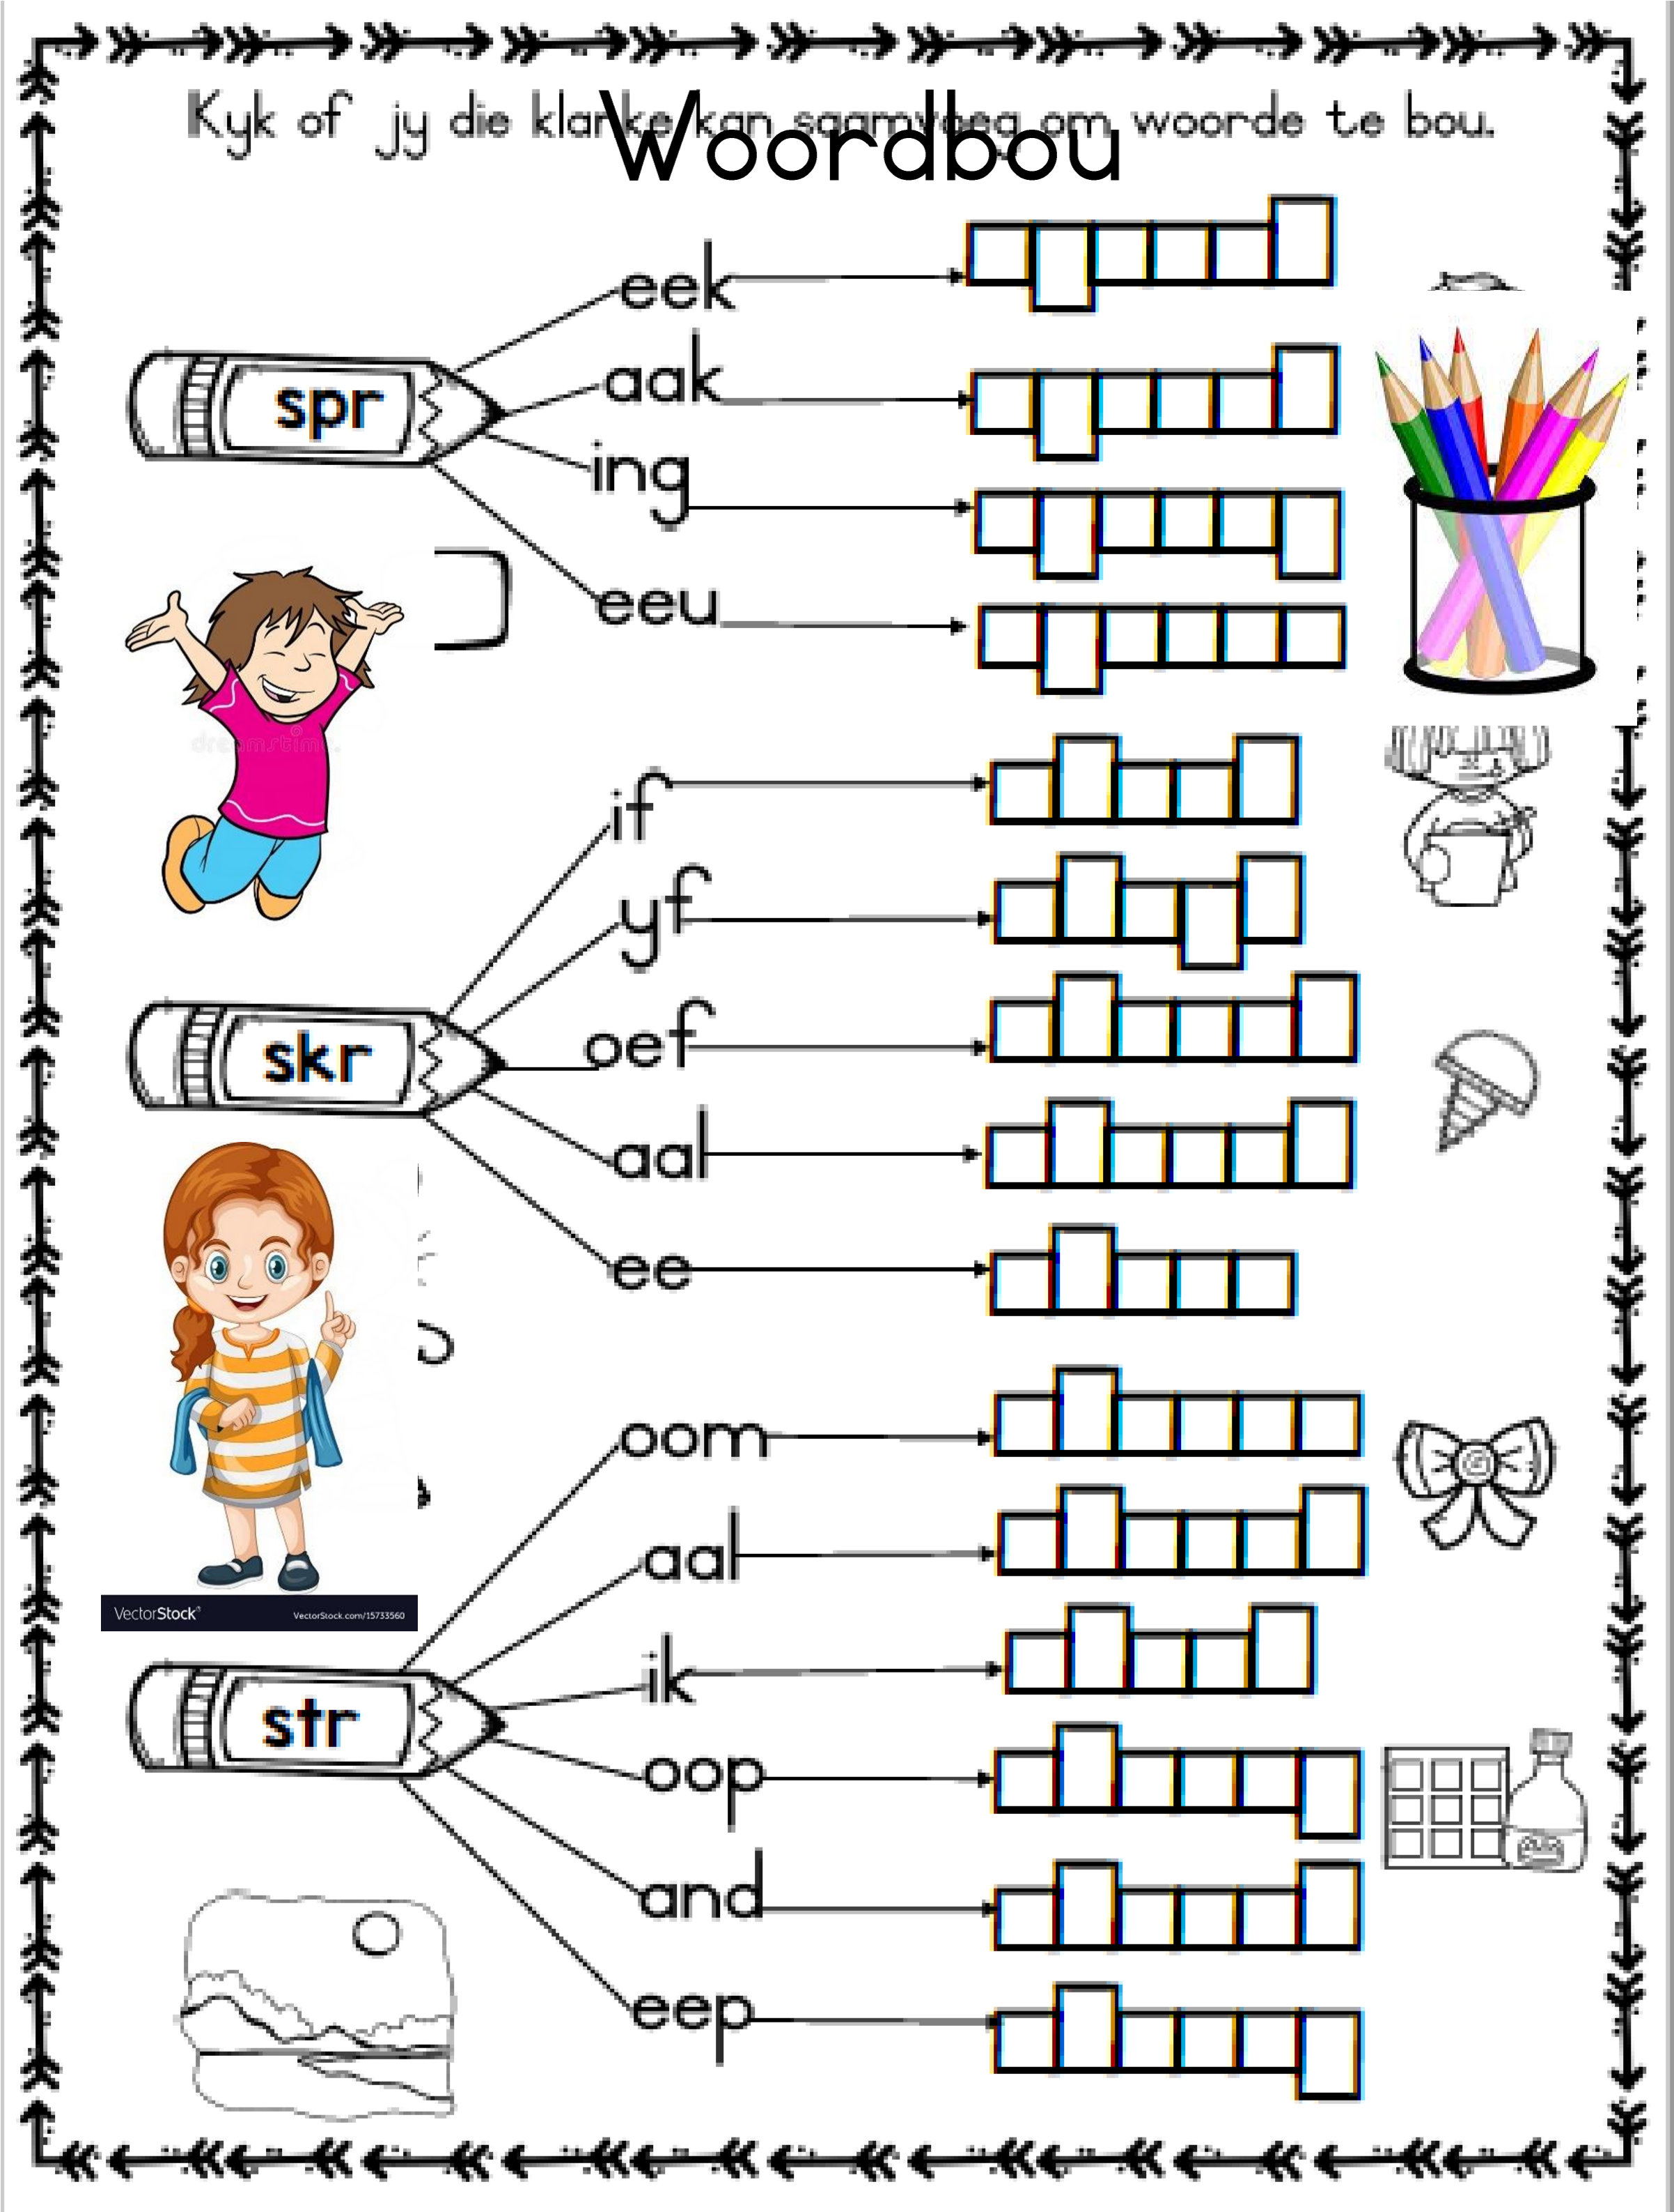

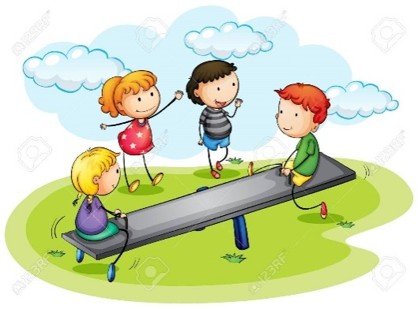

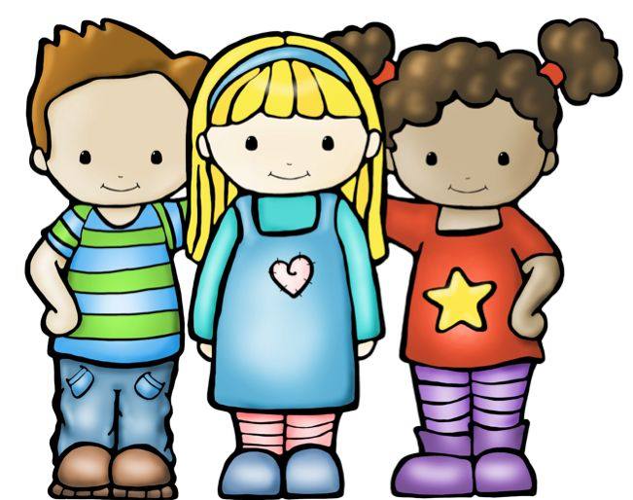
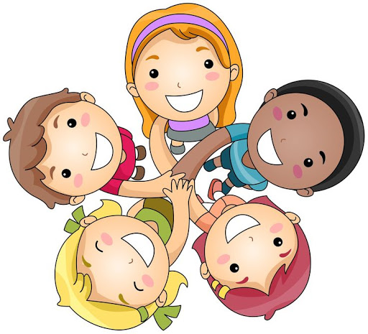

DATUM:
LEESBEGRIP. (READING COMPREHENSION)
20 punte

Lees die volgendeinformasieleesstukkeenbeantwoord die vrae in volsinne.
(Read the following information passages and then answer the questions in full sentences)

LEESSTUK A:

SPINNEKOP

‘nSpinnekop is siesa! Hy het agt (8) lang bene enhy het meer as twee (2) oë. Hulle is vol hare en het ‘n grootlyfen ‘n kleinkop.Hulleeetgoggassoos ‘n vlieg, miereen motte. Hulle spin ook ‘n web om in teblyenkostevang. Pasopvir die spinnekop!Ashyjoubyt is jydalk net joulewekwyt!
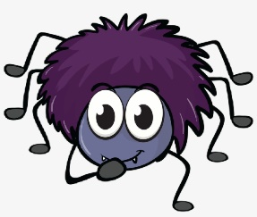

1. Hoeveel bene het ‘n spinnekop?

_________________________________________________________________________(1)

2. Watterdriegoedeet ‘n spinnekop?

__________________________________________________________________________(3)

3. Dink jy ‘n spinnekop is gevaarlik (dangerous)? Hoekomsêjy so?

______________________________________________________________________________

___________________________________________________________________________(2)

4. Waarbly ‘n spinnekop?

__________________________________________________________________________(1)

5. Hoe lyk die spinnekop se lyf?

____________________________________________________________________________

____________________________________________________________________________

_________________________________________________________________________(3)
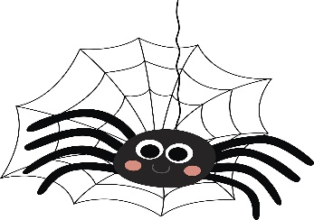

LEESSTUK B:

MINA KOEI

Mina die melk-koeieetgroengras in die veld. Sy is wit met swart kolleoorhaar hele lyf. Sybly op die boer se plaas in die Vrystaat. Sy gee vir die boerlekkervarsmelk wat hykan drink. Mina Koei het twee grootoëen ‘n lang, pienk tong. Sy is lekker vet enhounie van hardloopnie. Mina Koei houbaie van kinders. Hullemaakhaarbly.
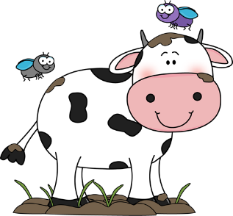

1. Waarbly Mina Koei?

___________________________________________________________________________(1)

2. Wat gee syvir die boer?

___________________________________________________________________________(1)

3. In watterprovinsie is die boer se plaas?

___________________________________________________________________________(1)

4. Hoe lyk die koei se lyf?

_____________________________________________________________________________

__________________________________________________________________________(2)

5. Waarvanhou Mina Koei baie?

__________________________________________________________________________(1)

6. Houjy van melk? Gee ‘n redevirjouantwoord.

_____________________________________________________________________________

__________________________________________________________________________(2)

7. Wat eet Mina die koei?

__________________________________________________________________________(1)

8. Waarkrysyhaarkos?

__________________________________________________________________________(1)

DATUM:
TALLEER : ANTONIEME / TEENOORGESTELDES (OPPOSITES)
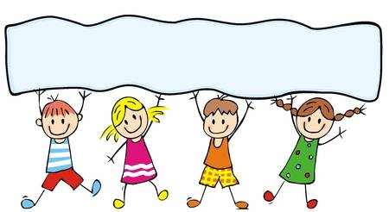
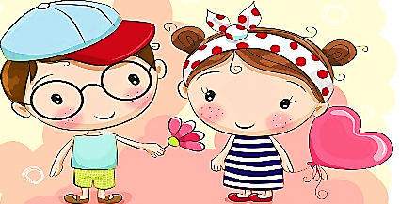
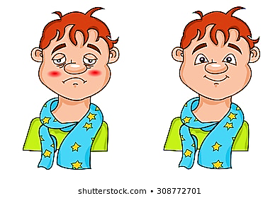
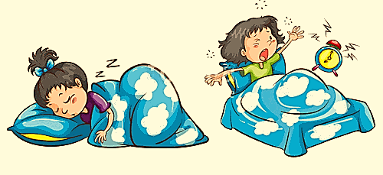
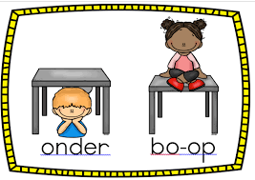
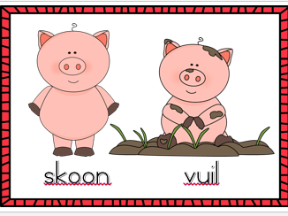
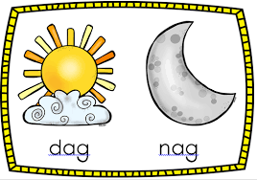
WOORDE MET VERSKILLENDE BETEKENISSE.
(WORDS WITH THE OPPOSITE MEANING)
bo-op onder
inuit
seunmeisie
siekgesond
slaapwakker
grootklein
oop toe
natdroog
vooragter
skoonvuil
dag nag

LEER DIE VOLGENDE ANTONIEME
(Learn these opposites)

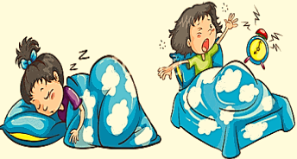
DATUM:
TAALOEFENING
30punte

1. Pas die volgendewoorde in die tabelgegee by die korrekt antonym. Skryf die antwoord.
(Fit the words given in the table below, to the correct opposite meaning.)

ongelukkig | vas | siek | maer | afsit
lui | huil | pappa | agter | nag
kort | lelik | baie | laag | donker

1.Lag -________________________ 2.Aansit -________________________

3.Min -________________________ 4.Fluks -________________________

5.Gesond -________________________ 6.Voor -________________________

7.Lank -________________________ 8.Vet -________________________

9.Lig -________________________ 10. Los -________________________

11.Gelukkig -________________________ 12.Mamma -________________________

13.Dag -________________________ 14.Mooi -________________________
15.Hoog -________________________

2. Vindnou die antonieme in die blokgegee, in die woordsoekaktiwiteit.
(Now find the opposite words in the block above,in the wordsearch below.)

ongelukkig | vas | siek | maer | afsit
lui | huil | pappa | agter | nag
kort | lelik | baie | laag | donker
(Woordekan op of af, links of regs, skyns of agterstevoor wees.)

O | M | I | L | U | I | E | R | H | U | I | L
N | S | K | U | I | L | A | L | A | A | G | E
G | G | I | P | N | A | G | R | D | R | E | L
E | O | N | E | B | A | R | E | D | T | O | I
L | R | Y | U | K | C | V | T | M | N | U | K
U | D | O | N | K | E | R | G | J | K | L | H
K | U | T | A | L | B | E | A | M | A | T | U
K | G | R | B | Y | O | P | L | E | M | G | A
I | U | O | N | V | P | K | I | B | A | I | E
G | H | K | M | A | A | A | U | A | E | P | A
R | J | V | P | S | L | S | Y | I | R | P | I
Q | A | F | S | I | T | T | H | N | M | O | E

DATUM:
KREATIEWE WERK
SKRYF VAN PARAGRAWE.

Kykna die prentjiesgegeeenskryfdan 5 sinnevirelkeprent. Jousinnemoetbeskrywend wees enmoet wees oor wat jy in die prentjiesien. Doeneersjullebeplanningengebruikasseblief ‘n woordeboek.

(Look at the pictures given and write 5 sentences for each picture. Your sentences must be descriptive and must be about what you see in each picture. Do your planning first on the lines below and please make use of a dictionary.)

BEPLANNING (PLANNING)

PRENT 1:___________________________________________________________________

______________________________________________________________________________

______________________________________________________________________________

______________________________________________________________________________

______________________________________________________________________________

______________________________________________________________________________

PRENT 2:____________________________________________________________________

______________________________________________________________________________

______________________________________________________________________________

______________________________________________________________________________

______________________________________________________________________________

______________________________________________________________________________

PRENT 3:___________________________________________________________________

______________________________________________________________________________

______________________________________________________________________________

______________________________________________________________________________

______________________________________________________________________________

______________________________________________________________________________

FINALE WERK (FINAL WRITING)
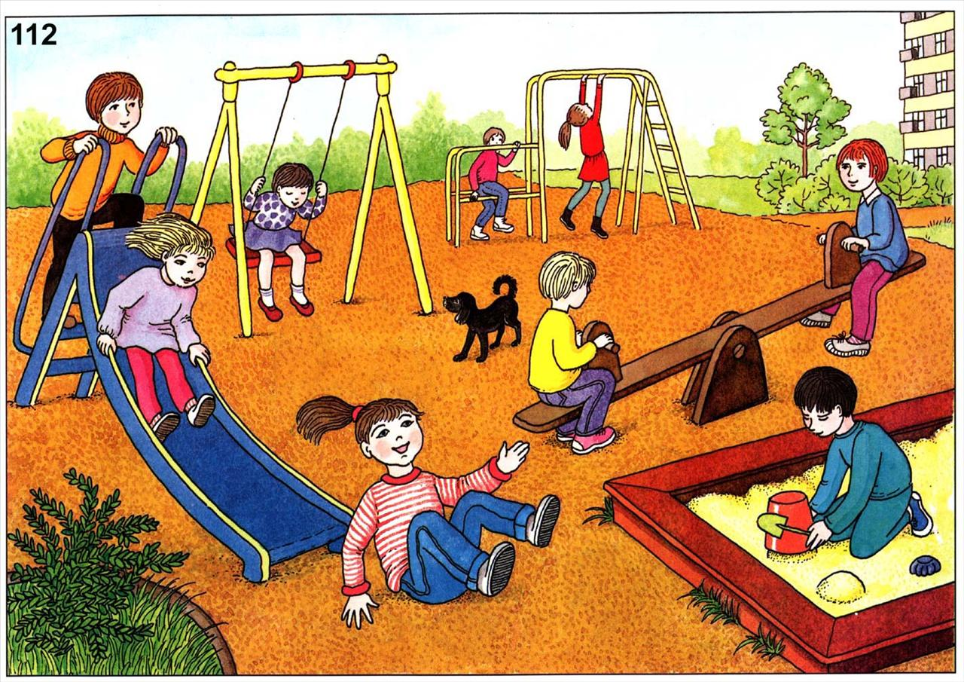
PRENT 1:

______________________________________________________________________________

______________________________________________________________________________

______________________________________________________________________________

______________________________________________________________________________

______________________________________________________________________________

______________________________________________________________________________

______________________________________________________________________________

______________________________________________________________________________

______________________________________________________________________________

______________________________________________________________________________

______________________________________________________________________________

______________________________________________________________________________

______________________________________________________________________________

______________________________________________________________________________

______________________________________________________________________________

PRENT 2:
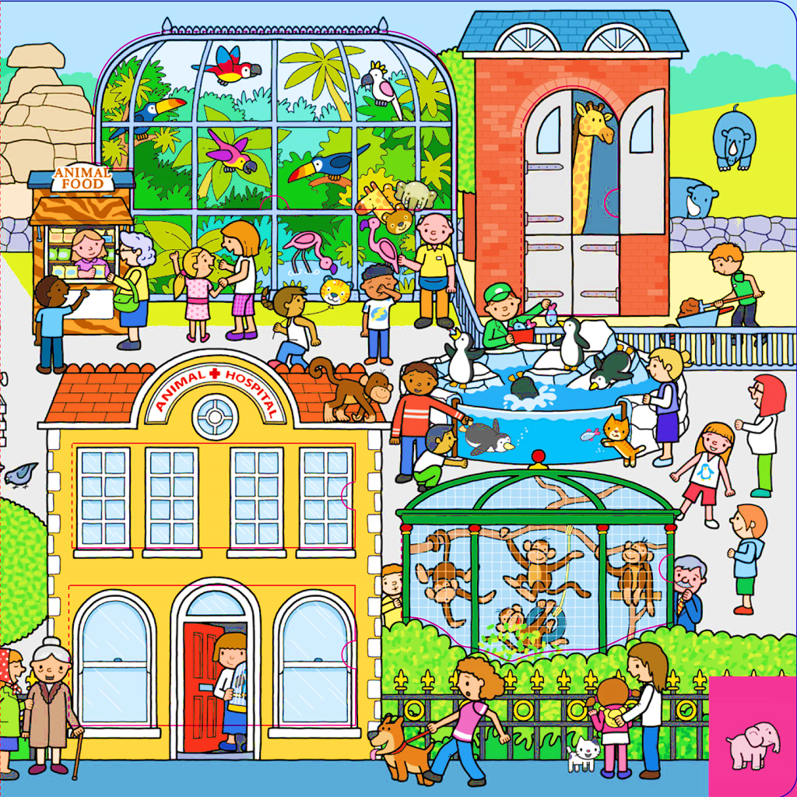

______________________________________________________________________________

______________________________________________________________________________

______________________________________________________________________________

______________________________________________________________________________

______________________________________________________________________________

______________________________________________________________________________

______________________________________________________________________________

______________________________________________________________________________

______________________________________________________________________________

______________________________________________________________________________

______________________________________________________________________________

______________________________________________________________________________

______________________________________________________________________________

______________________________________________________________________________

______________________________________________________________________________

PRENT 3:
































