AFRIKAANS F.A.L
WORKBOOK 2

29 JUNE – 03 JULY 2020

AFRIKAANS F.A.L
GRADE 4
WEEK OF 29 JUNE – 03 JULY
LOCKDOWN 2020

DAG 1  MAANDAG | - We are doing reading activities today. You have to read the poem about “WippieenSnippie.” They are mice and are best friends. They live in a whole in the wall and they play outside their hole, until the fat cat arrives, then they just run back into the hole in the wall.  - Read through the poem to yourself and then to a parent.  - Now find the English meanings for the spelling words. Draw a picture to show the meaning of the words in the space given.  - Now try and answer the comprehension questions about the poem.
DAG 2  DINSDAG | - Today is all about learning new concepts.  - You have to read through the rules about doing words (verbs). These words show the actions that people or animals do, they also give a sentence meaning. Read through the different verbs given and learn these in Afrikaans.  - Now do the activities to practise the new language you have learned today.  - Good luck and do your best!!!
DAG 3  WOENSDAG | - Today I want you to read the poem again, using facial expressions and different tones of voice. Imagine you are angry, or use a girly voice.  - We are also going to learn about singular sentences today. These sentences are sentences that have only one doing word (verb). They are easy to read and easy to write.  - Now look at the pictures on the worksheet and try to write a good Afrikaans sentence for each picture. Remember to make use of verbs!!!  - If you get stuck: Remember a dictionary is your friend!!!!!
DAG 4  DONDERDAG | - Today we are using our imaginations to do some creative writing. You have to write a newspaper article about funny news. Maybe the dog did a funny trick or your baby brother slipped on a banana peel. Who knows? You do!! So write it down in Afrikaans and draw a nice picture to show your news. Remember to also give your newspaper a name.  - I cannot wait to hear your funny news!!!
DAG 5  VRYDAG | - Today you must make a video of yourself performing the poem about WippieenSnippie. When you are done you can send the video to a family member, to show them how cool you are when doing Afrikaans!!!  - Also use an Afrikaans magazine, newspaper, advertisement or any other Afrikaans media to find 10 verbs. Cut these verbs out and stick them in the circles on the activity page. Now cut out the frame, decorate it and look at the nice verb-frame you made.  - Go and enjoy a well-deserved weekend now!!!

DATUM:_______________________________
LEES: (READING)
20 marks

Lees die gediggiegeneemvanaf FACEBOOK endoendan die aktiwiteite.
Read the poem taken from FACEBOOK and then do the activities to follow.
WIPPIE EN SNIPPIE

WippieenSnippieloeruit
By ‘n gaatjie
Wippie is ‘n muisie
EnSnippie is symaatjie.

WippieenSnippie,
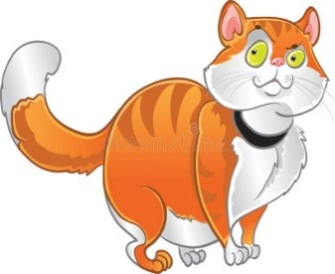
Daarkom die grootkat!
Woertsis die muisiesweer
Terug in die gat!

1. Soek die Engelsebetekenisvir die woorde. Teken ‘n prentjie om die betekenistewys.
(Find the English meaning for the words and draw a picture to show the meaning of each)

1.loer | 2.uit | 3. gaatjie | 4.muisie | 5.maatjie

6.kat | 7.woerts | 8.weer | 9.terug | 10.gat

2. Leesbegrip: Lees die vraeenbeantwoordhulle in volsinne. Die antwoorde is in die gedig.
Reading comprenension: Read the questions and answer in full sentences. The answers is found in the poem.

2.1 Skryf 2 werkwoorde (doing words) neer in gedig.

________________________________________________________________(2)

2.2 Wat is die muise se name?

________________________________________________________________(2)

2.3 Waarbly (stays) die muisies?

________________________________________________________________(1)

2.4 Wiemaakhulle bang (scared)?

________________________________________________________________(1)

2.5 Is die volgendestellings WAAR (true) of VALS (false)?
2.5.1 Hulle is vinnige (fast) muisies. WAAR / VALS

2.5.2 Die kat is groot. WAAR / VALS

2.5.3 Wippiehounie van Snippienie. WAAR / VALS

2.5.4 Die muisies is terug in die tuin. WAAR / VALS (4)

2.6 Teken ‘n prentjie van wat in die gediggiegebeur.
(Draw a picture, showing what happened in the poem)

DATUM:
TAALLEER:
WERKWOORDE
(DOING WORDS)

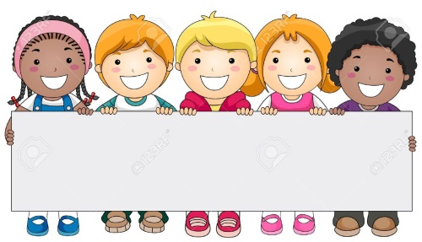

WOORDE WAT BEWEGING EN AKSIE WYS WAT ‘N PERSOON OF DING DOEN.

WORDS THAT SHOWS THE ACTIONS OR MOVEMENTS THAT PEOPLE OR THINGS DO.

 |  |  | 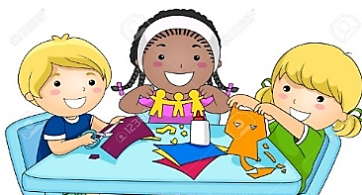
Spring - Jump | Leer - Learn | Hardloop - Run | Maak - make
Sit - Sit | Luister - Listen | Eet - Eat | Lees - Reading
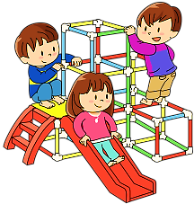 |  |  | 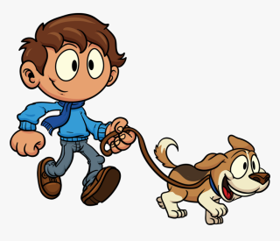
Speel - Play | Lag - Laugh | Gooi - Throw | Loop - Walk
Koop - Buy | Swem - Swim | Lek - Lick | Soek - Search
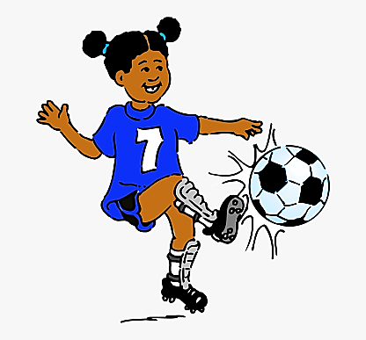

Skop - Kick | Praat - Talk | Sing - Sing | Dans - Dance

DATUM:
TAALOEFENINGE
15 PUNTE

1. ONDERSTREEP DIE WERKWOORDE IN ELKE SIN.
(Underline the verb in each sentence.)

1.1 Thabo speelelke dag in die tuin.

1.2 Ek lag vir my boetie.

1.3 Katlego sing ‘n Kurt Darren liedjie.

1.4 Owammielek die roomys.

2. SKRYF JOU EIE SINNETJIE VIR ELK VAN DIE WOORDE. GEBRUIK ‘N WOORDEBOEK.
(Write your own sentences, showing the meaning of the verbs. Use a dictionary.)

2.1 Loop - _________________________________________________________

___________________________________________________________________

2.2 Dans - _________________________________________________________

___________________________________________________________________

2.3 Lees - _________________________________________________________

___________________________________________________________________

2.4 soek - _________________________________________________________

___________________________________________________________________

3. PAS DIE PRENTJIE IN KOLOM A BY DIE WERKWOORD IN KOLOM B. TREK ‘N STREEP.
(Fit the picture in column A to the doing word in column B. Draw a line between them.)

Kolom A | ANTWOORDE | Kolom B
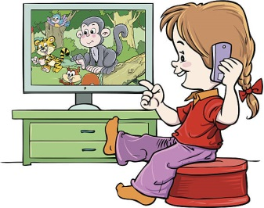 |  | A. WERK
 |  | B. DINK
 |  | C. WAS
 |  | D. KYK

4. KYK NA DIE WOORDE GEGEE EN SKRYF DIT IN DIE REGTE SINNE.
(Look at the words given and add them to the correct sentence.)

Soekeetslaap

4.1 Nonnie, die hond ___________________haarhondekos.

4.2 Die kinders ____________________________niehuiswerknie.

4.3 My ma __________________in haargroot bed.
Goeiewerk!!! Jy het nou hard gewerkengoedgedoen!!

DATUM:
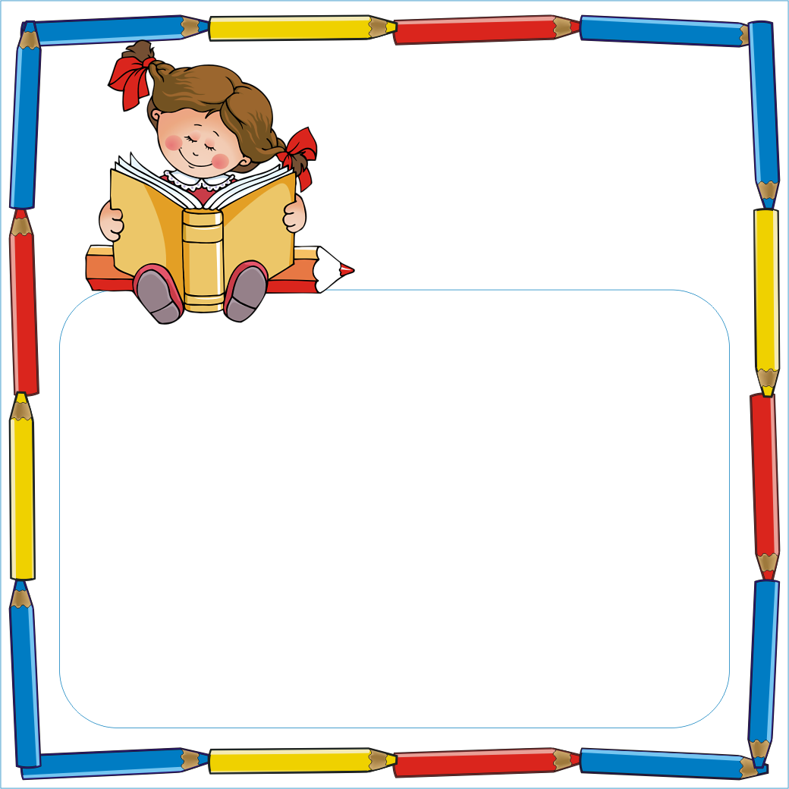
TAALLEER:
ENKELVOUDIGE SIN
SINGULAR SENTENCE
(Simple tense)

Enkelvoudigesinne is sinne met net 1 (een) werkwoord.
Daar is iemand wat die aksiedoeneniemand wat die aksievoel.

It is when we write sentences in the simple tense.
You have 1 (one) verb in the sentence.
There is one person doing the action and one feeling the action.

Voorbeelde:
1. Die kinders bad in die aand.
(The children bath in the evening.)

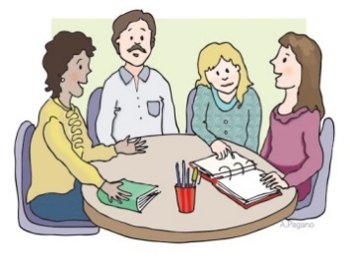

2. Die mense sit by die tafel.
(The people sit at the table)

3. Die seun sing mooi.
(The boy sings beautifully)

DATUM:
TAALOEFENINGE
6 PUNTE

Kykna die prentjiesvirjougegeeenskryfdan ‘n enkelvoudige sin virelkeprentneer.
(Look at the pictures given and write a singular sentence down for each of the pictures.)

Die kind swem in die water.
Voorbeeld:
Example:

____________________________________  ____________________________________ |  | _____________________________________  _____________________________________
____________________________________  ____________________________________ |  | _____________________________________  _____________________________________
____________________________________  ____________________________________ |  | _____________________________________  _____________________________________

Datum:
Kreatiewewerk: ‘n Nuusberig

Skryf ‘n nuusberigoorenigesnaaksenuus wat jy het. Onthouomvirjoukoerant ‘n naamookte gee endan ‘n prent van jounuusteteken.
(You have to write a newspaper article about funny news.So write it down in Afrikaans and draw a nice picture to show your news. Remember to also give your newspaper a name.)

My koerant se naam:
____________________________________________

My snaaksenuus is:
_________________________________________________________
_________________________________________________________
_________________________________________________________
_________________________________________________________
_________________________________________________________
_________________________________________________________
_________________________________________________________
_________________________________________________________
_________________________________________________________
_________________________________________________________

My prentjieoor my nuus:

Datum:
Kreatiewewerk: ‘n woordraam

1. Maak ‘n video van jouselfwaarjy die gediggieWippieenSnippieopvoerenstuurditdanvirjoufamilieomtesien.
(Today you must make a video of yourself performing the poem about WippieenSnippie. When you are done you can send the video to a family member.)

2. Soekvir 10 (tien) Afrikaansewerkwoorde in enigeAfrikaanse media, tydskrif of koerant. Plak die woordenou in ‘n borrelenkleurdanjouwoordraam in.
(Use an Afrikaans magazine, newspaper, advertisement or any other Afrikaans media to find 10 verbs. Cut these verbs out and stick them in the circles on the activity page. Now cut out the frame, decorate it and look at the nice verb-frame you made.)

