Grade 4 term 2 work
Map skills
Unit 4: Compass direction

Compass directions are a special way of describing where places are. We use compass directions instead of words like left, right, top, and bottom. The four main compass directions are north, south, east and west.
Here is another fun way to remember the 4 compass points: N.E.S.W which also stands for Never Eat Slippery Worms.
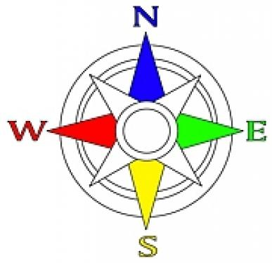

Activity 1
From what you have learnt above about the 4 main compass points, here is a simple task to complete in order to see how much you understand.

1.1: Complete the following activity using the 4 compass points.
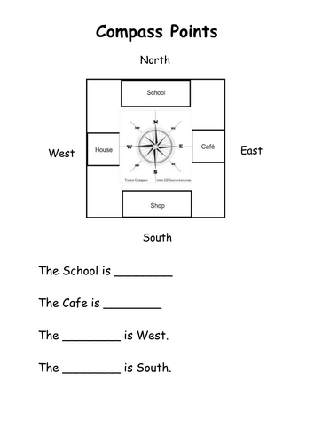
Now that you have learnt about the 4 main compass points, it will be easy to introduce the other 4 points that lie in between the main 4 pointswhich are called: North East, South East, North West and South West. Study the picture below to see where the other four points are situated.
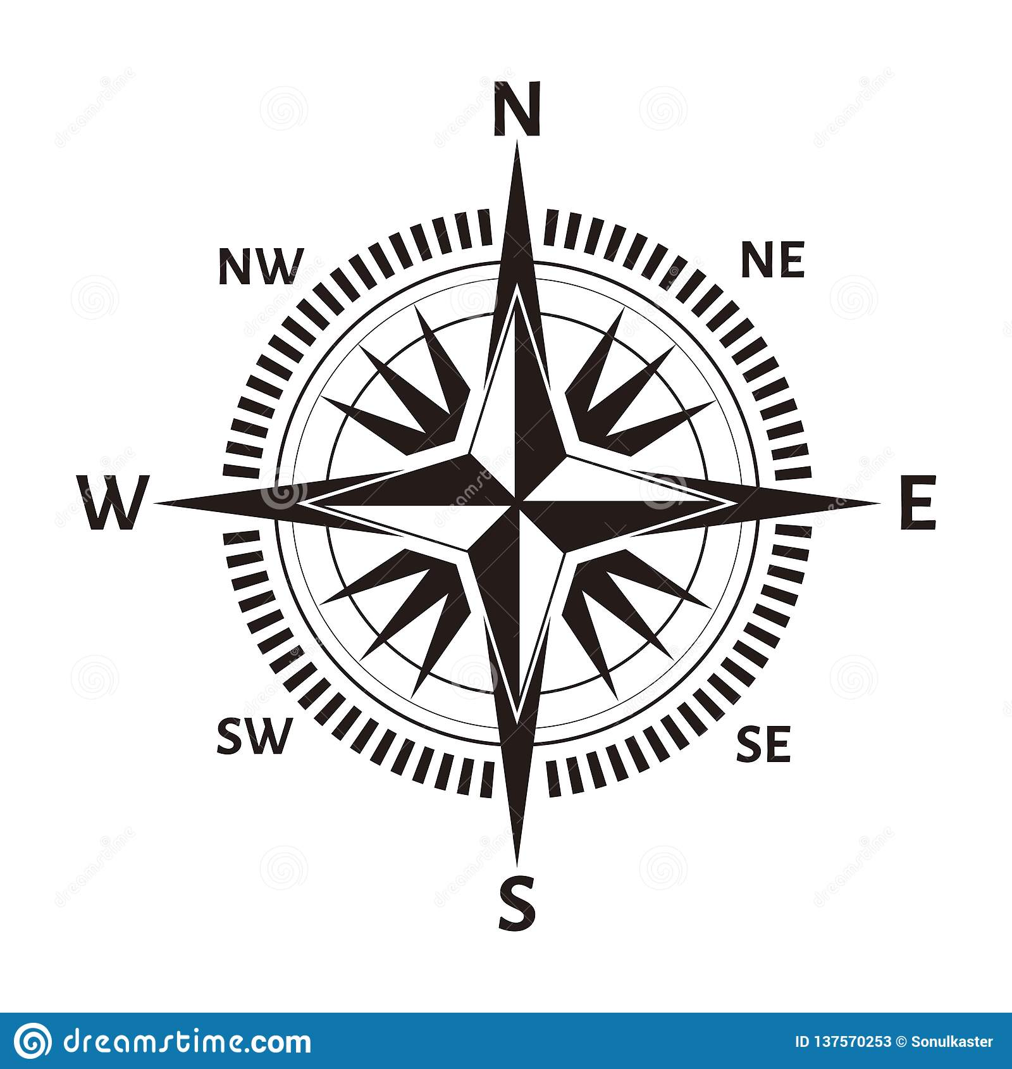
Now that you have studied the diagram above, answer the questions below using the 8 compass points.

Activity 1.2: Complete the following activity using the 8 compass points.

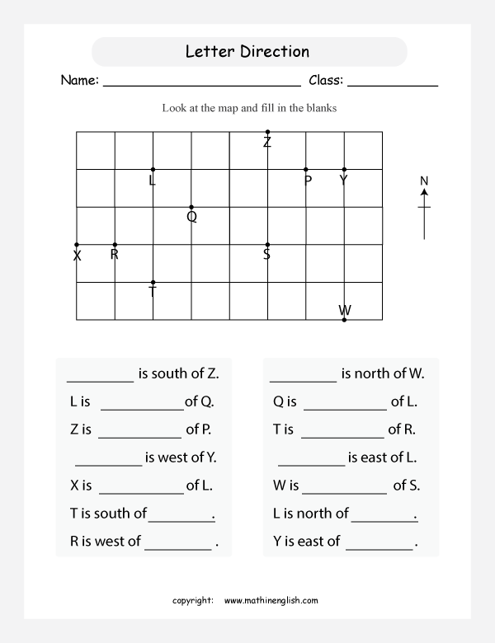

Unit 5: Map of South Africa.
Word bank
Capital city: The centre of government in a province or a country.
Coast: The place where the land and sea meet.
Provincial: To do with a province

- South Africa is a country in the South of Africa.
- The place where the land meets the sea is called the coast or the coastline.
- The oceans are large areas of salt water. There are two oceans next to South Africa which are theIndian Ocean that lies on the East of South Africa and the Atlantic Ocean that lies on the west of South Africa.
- People have divided South Africa into smaller areas called provinces. South Africa has 9 provinces. Each province has a capital city.
Study the map below with only the 9 provinces of South Africa and then answer the questions that follow.
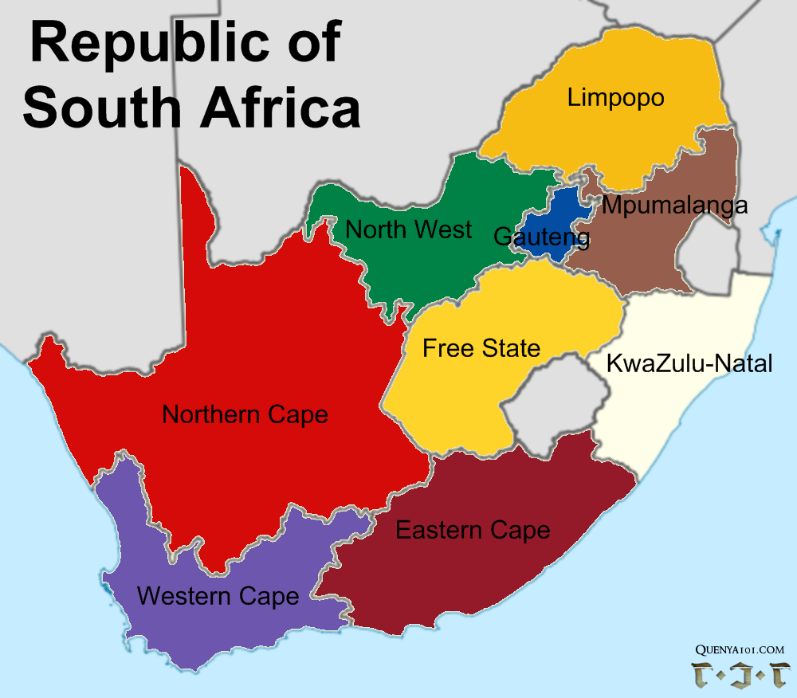

Activity 2: use the map of South Africa to answer the questions that follow.
2.1.List the nine provinces of South Africa
______________________________________________________________________________________________________________________________________________________________________________________________________________________________________________________________________________________________________________________________________________________________________________________________________________________________________________________________(9)
2.2.Name the province which you live in?
______________________________________________________________________________________________________________________________________________________________________________________________(2)

2.3.Using the 4 compass points answer which province is:
A) North from your province______________________________________
B) South from your province______________________________________
C) East from your province_______________________________________
D) West from your province______________________________________

2.4. The blue part on the map symbolises the two oceans that surround South Africa.
Name the 4 provinces that are along the coast/next to the ocean.
______________________________________________________________________________________________________________________________________________________________________________________________________________________________________________________________________________________________________________________________________________________________________________________________(4)

The next map of South Africa shows the 9 provinces of South Africa, CapitalCitiesandthe two oceans that surround South Africa. Study the map and answer the questions that follow.

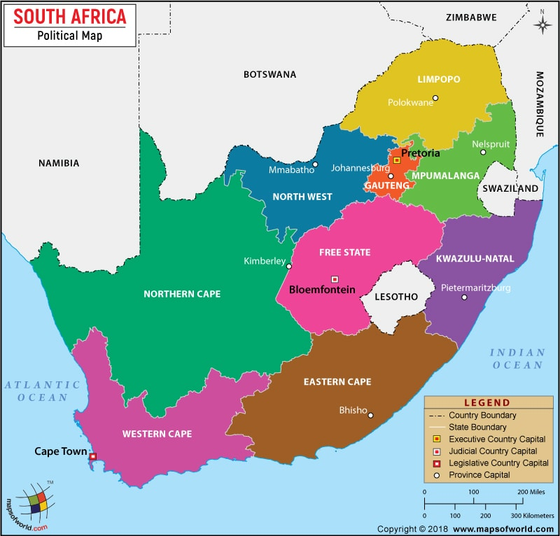

2.5. List the 9 provinces of South Africa and their capital cities. One has been already done for you.
A) Gauteng – Johannesburg
______________________________________________________________________________________________________________________________________________________________________________________________________________________________________________________________________________________________________________________________________________________________________________________________________________________________________________________________________________________________________________________________________________________________________________________________________________________________________________________________________________________________________________________________(8)
2.6. Name the 4 neighbouring countries of South Africa.
______________________________________________________________________________________________________________________________________________________________________________________________________________________________________________________________(4)
2.7. List the two countries within South Africa.
______________________________________________________________________________________________________________________________________________________________________________________________(2)
2.8. Explain how is the Country boundary different to the State boundary?
______________________________________________________________________________________________________________________________________________________________________________________________________________________________________________________________________________________________________________________________(4)
2.9. Name the two oceans that lie on the East and West of South Africa.
______________________________________________________________________________________________________________________________________________________________________________________________(2)
2.10. Explain what the Executive country capital, Judicial country capital and legislative country capital mean. You may use the dictionary to explain your answer or ask your parent to assist.
______________________________________________________________________________________________________________________________________________________________________________________________________________________________________________________________________________________________________________________________________________________________________________________________________________________________________________________________________________________________________________________________________________________________________________________________________________________________________________________________________________________________________________________________(6)
2.11. State which province is the biggest and which is the smallest.
______________________________________________________________________________________________________________________________________________________________________________________________(2)
Unit 6: A globe and map of the world
The world is round like a ball. The pictures below show how the world looks from space. The globe is an object built to show how planet earth looks from space.
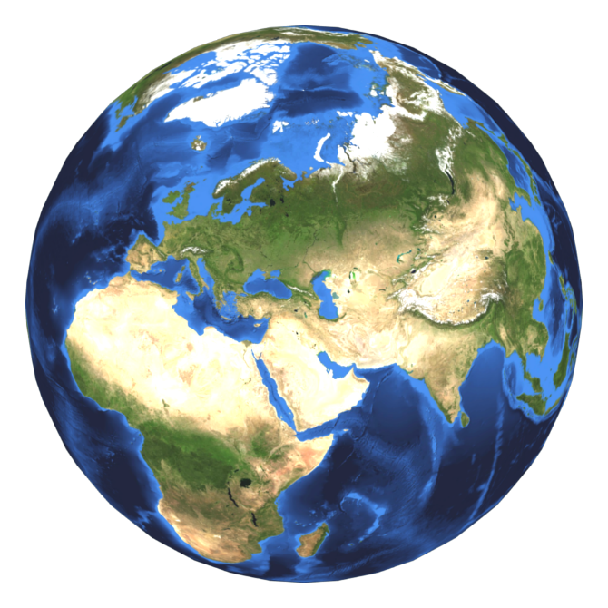
The picture above shows how planet earth looks from space.
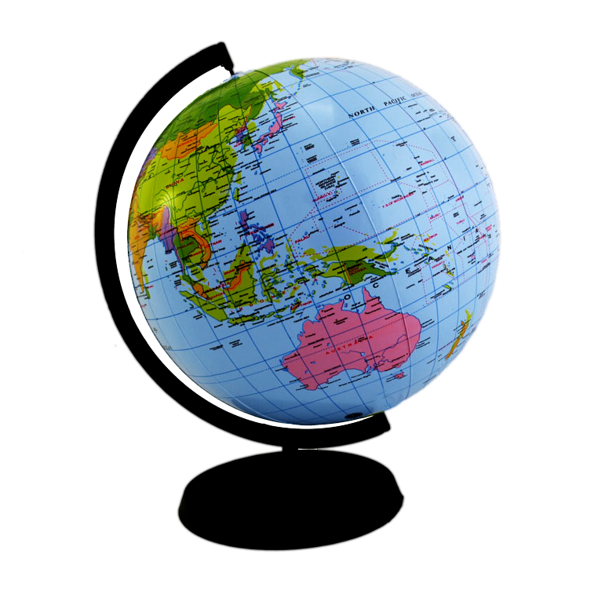

The picture above shows how planet earth looks on the globe. Ask your teacher to show you the globe in class.

Next is the map of the world which shows the globe and planet earth spread on a flat piece of paper. The map of the world shows the seven continents of the world, the main oceans and some of the islands.
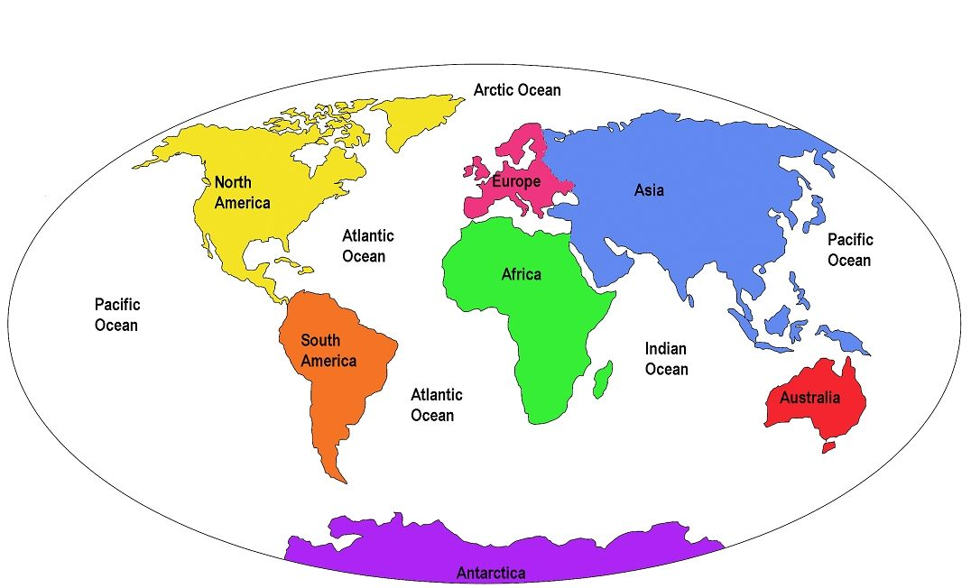

- A continent is a very large area of land. The world has seven continents.
- An ocean has large area of salt water. The world has three major oceans.
- A country is an area of land surrounded by a border and run by a government.
- A border is an invisible line that divides one country from another.

Activity 3: Use the world map to answer the questions that follow:
3.1. List the seven continents of the world.
__________________________________________________________________________________________________________________________________________________________________________________________________________________________________________________________________________(7)
3.2. Which continent is the furthest south?
____________________________________________________________________________________________________________________________________(2)
3.3. Which continent is East of Europe?
____________________________________________________________________________________________________________________________________(2)
3.4. Which continent is East of Africa?
____________________________________________________________________________________________________________________________________(2)
3.5. Name the 5 main oceans of the world.
_______________________________________________________________________________________________________________________________________________________________________________________________________(5)
3.6. Which ocean is the biggest of them all?
____________________________________________________________________________________________________________________________________(1)
3.7. Which ocean is the second largest and third largest?
___________________________________________________________________________________________________________________________________(2)
3.8. Explain in your own words the difference between a continent and a country.
Start your answers like this:
- A continent is a…… ________________________________________________________________________________________________________________________________________________________________________________________(2)
- A country is a…… ________________________________________________________________________________________________________________________________________________________________________________________(2)

Memorandum

The words in bold are the answers.
Compass direction activities
Activity 1.1
- The school is North.
- The café is East.
- The house is west.
- The shop is south.
Activity 1.2
- S is south of Z
- Lis North- West of Q
- Z is North- West of P
- P is west of Y
- X is South-West of L
- T is south of L
- R is west of S
- Y is North of W
- Q is South-East of L
- T is South- East of L
- P is East of L
- W is South-East of S
- L is North of T
- Y is East of P

Activity 2
Map of South Africa answers
2.1. Limpopo, Mpumalanga, Kwa-Zulu Natal, Eastern Cape, Western Cape, Northern Cape, North West, Gauteng and Free state.
2.2. Gauteng
2.3. A) Limpopo B) Free State C) Mpumalanga D) North- West
2.4 The four provinces situated along the coast are: Eastern Cape, Western Cape, Kwa- Zulu Natal and Northern Cape.

2.5. A) Gauteng -Johannesburg
B) Limpopo- Polokwane
C) Mpumalanga- Nelspruit
D) Kwa- Zulu Natal- Pietermaritzburg
E) Eastern Cape – Bhisho
F) Western cape – Cape Town
G) Northern Cape- Kimberley
H) North- West- Mafikeng/Mmabatho
Free State- Bloemfontein
2.6. Namibia, Botswana, Zimbabwe and Mozambique.
2.7. Lesotho and Swazi- Land.
2.8. Country boundary is an invisible line that separates countries from one another. A country boundary is also called a border if a person wishes to visit another country they need to go through the border and they will require a visa to do that. Whilst a state boundary is an invisible line that separates the provinces within countries. For an example a state boundary separates Gauteng from Free State.
2.9. Indian and Atlantic Ocean.
2.10 National Executive Capital is in Pretoria this is where the state officials have their headquarters and it is from Pretoria that the country is run.

Legislative Capital is in Cape Town, this is where the parliament is situated and the laws are drawn.

Judicial Capital is in Bloemfontein, and this is where the supreme court of appeal sits. It is where the laws are interpreted.

2.11. The biggest province on the map is the Northern Cape and smallest is the Gauteng.

Activity 3
Answers to the world map.

3.1. North America, South America, Africa, Europe, Asia, Australia and Antarctica.
3.2. Antarctica
3.3. Asia
3.4. Australia
3.5. Pacific, Atlantic, Indian, Southern and Arctic Ocean.
3.6. Pacific
3.7. Atlantic and Indian Ocean.
3.8. A continent is a very large piece of land that contains countries
A country is within a continent e.g South Africa is at the South of Africa.

