Grade 4 term 2 Geography work
Unit 3: Symbols and keys
New words
- Symbols – A simple picture or letter that has a special meaning on a map.
- Key- A list on a map that explains what symbols on the map mean.

People who make maps draw symbols onto their maps to show where things are. For example, a little star may show a police station. Symbols are simple pictures or letters that have special meaning on a map. They make it easier to draw and read maps.
Maps usually have a key. The key lists and explains all the symbols used on the map.
Here is an example of a simple map of park with symbols on the left and a key on the right.
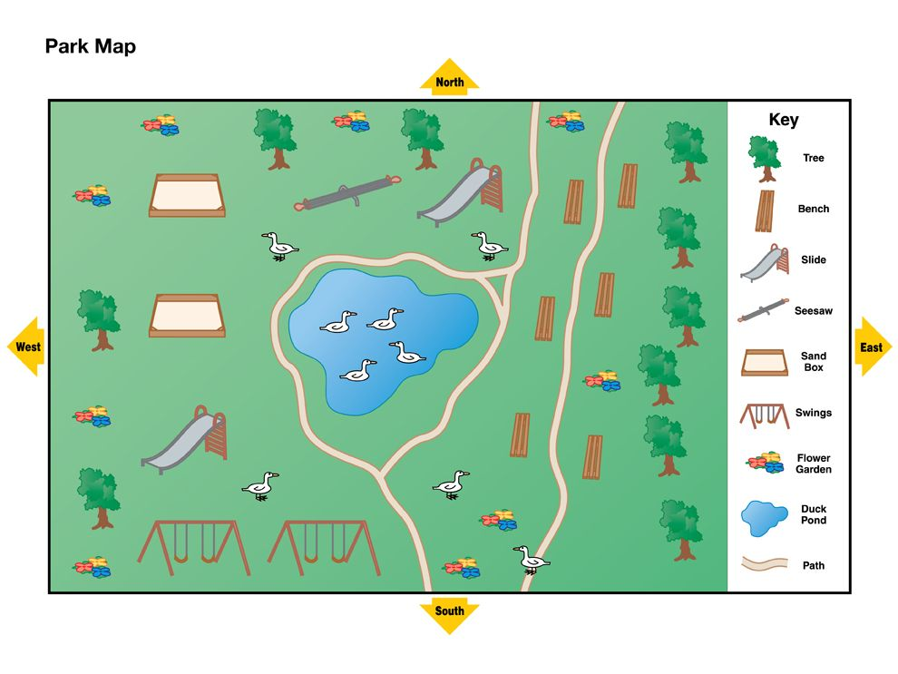
Complete the map below by adding the key to show what the symbols are.

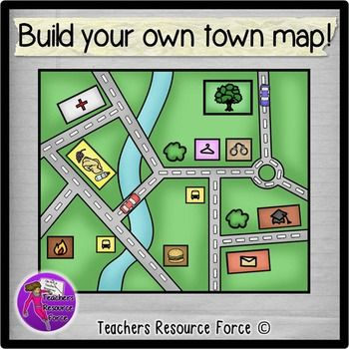

Activity 1: Complete the map above by drawing and labelling its key on the box below, do not forget to give each symbol a name.
12 marks.
Memorandum
These are the 12 symbols you need to draw and label in your key.
- Road
- Car
- Tree
- Clothing shop
- Police station
- School
- Post office
- Restaurant
- University
- Hospital
- River
- Grass

