TERM 2: COMMON FRACTIONS
Exercise 1
1. Answer the following questions.
For example: $\frac{2}{3}$ of 12 = (12 ÷ 3) × 2 = 8
a. $\frac{1}{5}$ of 10 = __________ | b. $\frac{3}{7}$ of 14 = __________
c. $\frac{4}{8}$ of 16 = __________ | d. $\frac{5}{9}$ of 18 = __________

2. Order these fractions from smallest to biggest [since their denominators are the same, order them from the smallest numerator to the biggest].
For example: $\frac{3}{4}$; $\frac{1}{4}$; $\frac{4}{4}$; $\frac{2}{4}$ = $\frac{1}{4}$; $\frac{2}{4}$, $\frac{3}{4}$; $\frac{4}{4}$
a. $\frac{4}{5}$; $\frac{1}{5}$; $\frac{3}{5}$; $\frac{2}{5}$  __________________________________ | b. $\frac{6}{8}$; $\frac{2}{8}$; $\frac{4}{8}$; $\frac{3}{8}$; $\frac{7}{8}$; $\frac{5}{8}$; $\frac{1}{8}$  _________________________________

3. Count forward in fractions.
For example: 1 + $\frac{1}{2}$ 1$\frac{1}{2}$ + $\frac{1}{2}$ 2 …
a. Count in thirds, from $\frac{1}{3}$ to $3\frac{2}{3}$  _______________________________________  _______________________________________  _______________________________________  _______________________________________ | b. Count in fifths from $\frac{2}{5}$ to $3\frac{3}{5}$  _______________________________________  _______________________________________  _______________________________________  _______________________________________

4. Count backwards in fractions.
a. Count in sixths, from $2\frac{5}{6}$ to $\frac{1}{6}$  _______________________________________  _______________________________________  _______________________________________  _______________________________________ | b. Count in sevenths, from $2\frac{6}{7}$ to $\frac{2}{7}$  _______________________________________  _______________________________________  _______________________________________  _______________________________________
5. Replace * with <; > or =.
Use the Fraction Chart below.
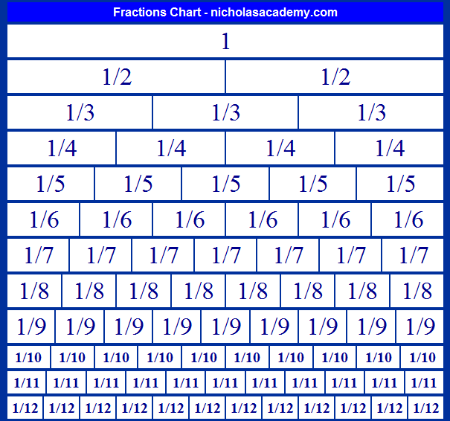
a. $\frac{1}{5}$ * $\frac{1}{4}$ _____ b. $\frac{2}{3}$ * $\frac{3}{5}$ _____ c. $\frac{3}{8}$ * $\frac{5}{6}$ _____ d. $\frac{9}{12}$ * $\frac{1}{2}$ _____ e. $\frac{2}{10}$ * $\frac{1}{5}$ _____ f. $\frac{2}{11}$ * $\frac{8}{9}$ _____

6. Order the following fractions from biggest to smallest [Use the Fraction Chart].
a. $\frac{1}{5}$; $\frac{1}{3}$; $\frac{1}{10}$; $\frac{1}{7}$  _______________________________________ | b. $\frac{2}{8}$; $\frac{4}{5}$; $\frac{6}{7}$; $\frac{1}{2}$; $\frac{2}{3}$  _______________________________________

Exercise 2
Adding and subtracting common fractions with the same denominators
1. Add the following fractions [add their numerators, keep their denominator].
For example: $\frac{2}{6}$ + $\frac{3}{6}$ = $\frac{5}{6}$
a. $\frac{1}{4}$ + $\frac{2}{4}$ = _____ b. $\frac{5}{10}$ + $\frac{2}{10}$ = _____ c. $\frac{1}{9}$ + $\frac{4}{9}$ + $\frac{2}{9}$ = _____ d. $\frac{5}{11}$ + $\frac{2}{11}$ + $\frac{1}{11}$ = _____
2. Subtract the following fractions[subtract their numerators, keep their denominator].
For example: $\frac{3}{5}$ - $\frac{2}{5}$ = $\frac{1}{5}$
a.$\frac{3}{4}$ - $\frac{2}{4}$ = _____ b. $\frac{9}{10}$ - $\frac{5}{10}$ = _____ c. $\frac{7}{8}$- $\frac{1}{8}$ - $\frac{2}{8}$ = _____ b. $\frac{6}{10}$ - $\frac{3}{10}$ - $\frac{2}{10}$ = _____
Exercise 3
1. Read the following and write down the fraction.
a. Wandile shared his marbles equally between 7 of his friends. What fraction of marbles did each one get?
______________________________________________________________________________________________________________________________________________________________________________________________________________________________________________________
b. Nkosi went to the aquarium for 6 out of the 10 days of holidays. What fraction of his time did he spend there?
______________________________________________________________________________________________________________________________________________________________________________________________________________________________________________________
c. Amanda wrote 5 out of the 7 pages for Social Science project on Monday. What fraction of her project has she done?
______________________________________________________________________________________________________________________________________________________________________________________________________________________________________________________
Exercise 4
Solve the word problems.
a. Jono used $\frac{1}{4}$ of his pocket money for sweets and used $\frac{2}{4}$ of his pocket money to buy a present for his grandmother. What fraction of his pocket money did he use altogether?
______________________________________________________________________________________________________________________________________________________________________________________________________________________________________________________
b. Sally spent $\frac{1}{5}$ of her day swimming and cycling and the other $\frac{2}{5}$ of her day running. What fraction of her day did she spend exercising?
______________________________________________________________________________________________________________________________________________________________________________________________________________________________________________________
c. Of the animals Tryllin saw in the game reserve, $\frac{5}{10}$ were impala, $\frac{2}{10}$ were elephants and $\frac{1}{10}$ were lions. What fraction was this of all the animals he saw?
______________________________________________________________________________________________________________________________________________________________________________________________________________________________________________________
d. A school decides to spend $\frac{5}{12}$ of the money collected at their school Walk-a-thon on books and $\frac{4}{12}$ of the money on sports equipment. What fraction altogether was spent buying books and sport equipment?
______________________________________________________________________________________________________________________________________________________________________________________________________________________________________________________
e. What fraction of the Walk-a-thon money was left over?
______________________________________________________________________________________________________________________________________________________________________________________________________________________________________________________

Exercise 5
Equivalent Fractions – are fractions that have the same value.
For example$: \frac{1}{2}$ =$\frac{2}{4}$ =$\frac{4}{8}$ =$\frac{5}{10}$ =$\frac{20}{40}$ =$\frac{50}{100}$ =$\frac{500}{1000}$ =$\frac{1000}{2000}$
1. Work out the equivalent forms for the following fractions by either multiplying or diving.
Example 1: $\frac{2}{3}$ = $\frac{6}{a}$
a = [6 ÷ 2] × 3 = 9 or$\frac{2 ×3}{3 ×3}$ = $\frac{6}{9}$
Therefore: $\frac{2}{3}$ = $\frac{6}{9}$
Example 2: $\frac{10}{20}$ = $\frac{5}{b}$
b = 10 ÷ 5 = 2or $\frac{10 ÷ 2}{20 ÷2}$ = $\frac{5}{10}$
= 20 ÷ 2 = 10
Therefore: $\frac{10}{20}$ = $\frac{5}{10}$
$\frac{1}{2}$ = $\frac{a}{10}$  a = ______________________ | $\frac{b}{20 }$ = $\frac{3}{5}$  b = ______________________ | $\frac{3}{8}$ = $\frac{9}{c}$  c = ______________________
d. $\frac{4}{d}$ = $\frac{2}{3}$  d = ______________________ | $\frac{5}{6}$ = $\frac{e}{24}$  e = ______________________ | $\frac{32}{40}$ = $\frac{4}{f}$  f = ______________________

REFERENCE
Barichievy M. and Pieterse K. (2012).Grade 5Shuters Premier Mathematics Learner’s Book. Shuter and Shooter.

