AFRIKAANS F.A.L
WORKBOOK 1

15-19 JUNE 2020

AFRIKAANS F.A.L
GRADE 4
WEEK OF 15 JUNE – 19 JUNE
LOCKDOWN 2020

DAG 1  MAANDAG | - Revision: sounds and phonics. Remember the Afrikaans sounds you did. Look at the language page and refresh your memory by practising the pronunciation of each letter and the words that go with it.  - Now write down 1 of your own word for each of the sounds. Use a dictionary for this. Write down your words inside the flowers in the word tree. Then colour the word tree to make it creative.
DAG 2  DINSDAG | - YOUTH DAY. Have a great day.
DAG 3  WOENSDAG | - Practise the following worksheets. These are there to build new words. After you have written the word in the space provided, read it out loud to your family and ask them the meaning. Have a test to see who in your house can translate the most words.
DAG 4  DONDERDAG | - Read the reading page of Faans en Maans. It is about a mouse who went to visit his cousin on the farm and then his cousin visited him in the city. It tells of what the two of them did.  - Now look at the underlined words. These are our focus words. Write the English meaning of each word down and draw a picture to show the meaning.
DAG 5  VRYDAG | - Creative writing: Look at the words given, from this week’s work. Now write a good Afrikaans sentence for each of the words given to you. Then draw a picture to show what you have read in the story about Faans en Maans.

DATUM:
KLANKE EN FONETIESE KLANKE.

Lees die volgendewoordehardopenoefen you klankuitspraak.
(Practise the pronunciation of the sounds and pronounce the words.)
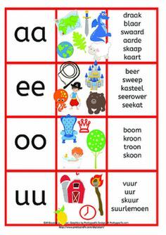
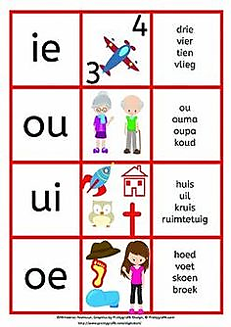

Skryfnou1 van joueiewoordeneer met elkeen van die klanke. Skryfdit in die blomme van die boom omjoueiewoordboomtevorm.
(Write down 1 of your own words for each of the sounds. Write them in the folwers, to create a word tree. Colour the tree when done.)

DATUM:
WOORDBOU AKTIWITEITE.
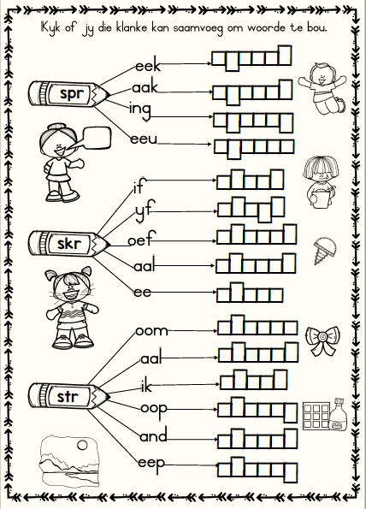

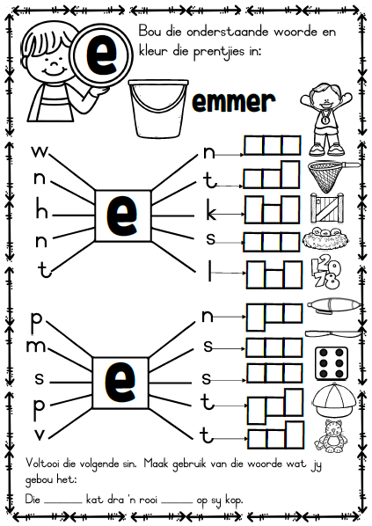

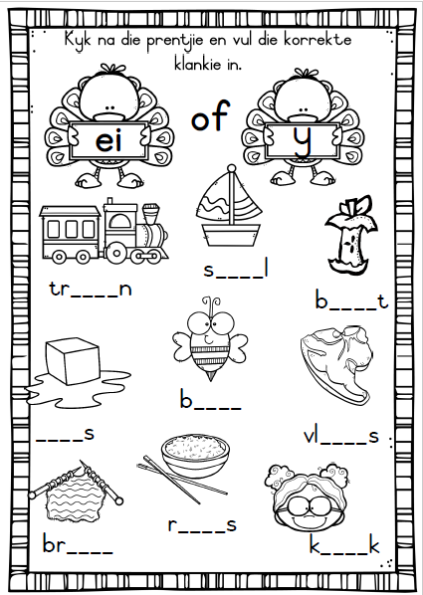

DATUM:_______________________________
LEES: (READING)

Maans en Faans.

MaansMuisgaan by sy neef speel, sy neef is Faans Muis wat op die plaas woon. O, dit is vir Maans lekker op die plaas! Hy en neef Faans gaan loer vir die hen wat broei. Maans steek sy hand uit na die hen. Hy wil aan haar sagtevere vat. . . Pik! Daar bloei Maans se poot! “Foeitog”, Neef! Kom ons gaan kyk na die koei.” Troos Faans. Hulle lê op hul magies en kyk of die groente al groei. Hulle roei op die rivier waar die water lekker vinnig vloei!

Nou is ditFaans se beurtom by Maans in die stad te gaan kuier. Faans se ogies blink soos al die stad se liggies, wat in die aand gloei! Hulle gaan fliek, ry met rolskaatse in die straat en stoei vir pret in die park! Voorwaar is die twee neefs baie goeie maats!
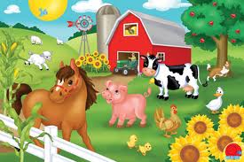

DATUM:
WOORDBANK. (SPELLING)

Soek die Engelse betekenis vir die woorde en teken ‘n prentjie om die betekenis van elk te wys.
(Find the English meaning for the words and draw a picture to show the meaning of each)

1. neef | 2. woon | 3. loer | 4. broei | 5. steek

6. sagte | 7. vere | 8. bloei | 9. poot | 10.foeitog

11.troos | 12.liggies | 13. groente | 14. groei | 15. roei

16. vloei | 17. beurt | 18. stad | 19. kuier | 20.ogies

21.gloei | 22.fliek | 23.rolskaatse | 24.stoei | 25. maats

DATUM:
KREATIEWE WERK.

SkryfAfrikaansesinnevir elk van dievolgendewoorde.
(Write Afrikaans sentences for each word.)

1. plaas - __________________________________________________________

__________________________________________________________________

2. stroom -__________________________________________________________

__________________________________________________________________

3. spring - __________________________________________________________

__________________________________________________________________

4. stoei - __________________________________________________________

__________________________________________________________________

5. gloei__________________________________________________________

__________________________________________________________________

2. Teken die storie van FaansenMaans. (Draw the story about FaansenMaans)

