**SURFACE AREA AND VOLUME OF 3D OBJECTS:** Surface area and volume

Consider the cube below which is made from small cubes of 1 $cm$ by 1 $cm$ by 1:

|  |  |  |
| --- | --- | --- |
|  |  |  |
|  |  |  |
|  |  |  |



**One face of the cube**

1. Use the Cube above to answer the following questions.
2. How many small cubes make up the big cube? 27 cubes
3. What is the volume of the big cube? $27 {cm}^{3}$
4. How many small cubes make up the first layer of the big cube? 9 cubes
5. How many cubes make up the length of each edge of the big cube?

3 cubes

1. Use the formula to calculate the area of the bottom face (base) of the big cube.

Area of the base $=s^{2}= {(3 cm)}^{2}=9 {cm}^{2}$

1. How many layers (height of the big cube) does the big cube have? 3 layers
2. Is there no other way that we can use to find the volume of the prism without counting the number of cubes which makes up the prism?

Yes, Volume of the cube $=$ Area of the base $×$ number of layers

$=$ Area of the base $×$ height

$$=s^{2}×s$$

$=9 {cm}^{2}×3 cm$

$$=27 {cm}^{3}$$

1. Calculate the area of each face of the big cube.

A cube has six (6) identical faces, see the net alongside

Surface area of a cube $=$ Sum of areas of all its faces

$$=9 {cm}^{2}+9 {cm}^{2}+ 9 {cm}^{2}+ 9 {cm}^{2}+9 {cm}^{2}+9 {cm}^{2}$$

$$=6×9 {cm}^{2}$$

$$=54 {cm}^{2}$$

Hence the surface area of a cube $=6×s^{2}$

**Activity 1**:

Calculate the volume of the following cubes.=

$$3 cm$$

Volume $=s^{3}$

$$={(3 cm)}^{3}$$

$$= {27 cm}^{3}$$

$$s$$

1. Volume $=s×s×s$

$$=s^{3}$$

**Note**: After learners’ calculations and teacher’s feedback no (b) is

Volume of a cube = *S³*

**Activity 2:**

Calculate the surface area of the cubes below.

$$3 cm$$

Surface area $=s^{2}×6$

$$={(3 cm)}^{2}×6$$

$$= {9 cm}^{2}×6$$

$= {54 cm}^{2}$

$$s$$

1. Surface area $=s×s×6$

$$=6 s^{2}$$

Surface area of a cube= 6*S²*

**SURFACE AREA AND VOLUME OF 3D OBJECTS:** Surface area and volume

Consider the following rectangular prism made from small cubes of $1 cm ×1 cm×1 cm$ and its faces.

|  |  |  |  |  |
| --- | --- | --- | --- | --- |
|  |  |  |  |  |
|  |  |  |  |  |
|  |  |  |  |  |
|  |  |  |  |  |
|  |  |  |  |  |
|  |  |  |  |  |
|  | (i)  (iii)  (ii) |  |  |  |



N.B.: Remember each of these faces has a replica.

1. Use the rectangular prism above to answer the following questions.
2. How many small cubes make up the rectangular prism? 210 cubes
3. What is the volume of the rectangular prism? 210 ${cm}^{3}$
4. How many small cubes make up the first layer of the rectangular prism? 30 cubes
5. How many cubes make up the length and breadth of the first layer (base)?

Length $=$ 6 cubes and the breadth $=$ 5 cubes

1. Use the formula to calculate the area of the bottom face (base) of the rectangular prism.

Area of the base $=l×b=6 cm×5 cm=30 {cm}^{2}$

1. How many layers (height of the rectangular prism) does the prism have? 7 layers
2. Is there no other way that we can use to find the volume of the prism without counting the number of cubes which makes up the prism?

Yes, Volume of the rectangular prism $=$ Area of the base $×$ number of layers

$=$ Area of the base $×$ height

$$=l×b×h$$

$$=6 cm×5 cm ×7 cm$$

$$=210 {cm}^{3}$$

1. Calculate the area of each pair of faces of the rectangular prism.

(a) $2(7cm × 5cm)$ (b) $2(6cm ×5cm)$ (c) $2(7cm × 6cm)$

$$= 2(35 cm²)= 2(30 cm²)=2(42 cm²)$$

$$=70 {cm}^{2}=60 {cm}^{2}=84 {cm}^{2}$$

1. What is the total surface area of the rectangular prism?

$70cm² + 60cm² + 84cm$ ² $=214 cm²$

Activity 1: What is the volume of these rectangular prisms?

(a) (b) (c)*h*

8cm 3cm

3cm 2cm 5cm 2cm*l b*

After learners’ calculations and teacher’s feedback no (c) is emphasised as a formula for calculating any given rectangular prism.

Volume of a rectangular prism = *l x b x h*

Activity 2: What is the surface area of these rectangular prisms?

(a) (b) (c)*h*

8cm 3cm

3cm 2cm 5cm 2cm *l b*

This what is expected from learners:

a) $2(8 cm$ x $3 cm) + 2(8 cm$ x $2 cm) + 2(3 cm × 2 cm)$

$$= 2(24 cm²) + 2(16 cm²) + 2(6 cm²)$$

$$= 48 cm² + 32 cm² + 12 cm²$$

$$= 92 cm²$$

b) $2(5cm$ x $3cm) + 2(3cm$ x $2cm) + 2(5cm × 2cm)$

$$= 2(15 cm²) + 2(6 cm²) + 2(10 cm²)$$

$$= 30 cm^{2}+ 12 cm^{2}+ 20 cm^{2}$$

$$= 62 cm²$$

(c) $2(l$ x $h)+ 2(b × h) + 2(l × b)$

$$= 2(lh + bh + lb)$$

Formula for calculating any given rectangular prisms

Surface area of a rectangular prism $= 2(lh + bh + lb)$

Revise with learners the following work done in lesson 1 by asking them to:

Determine the surface area and the volume of the following 3D shapes in the table.

|  |  |  |  |
| --- | --- | --- | --- |
| **Name** | **Object** | **Volume** | **Surface Area** |
| Cube | 3cm | $$V=s^{3}$$ $$=3^{3}{cm}^{3}$$ $$=27{cm}^{3}$$ | $$SA=6 ×s^{2}$$ $$=6 ×3^{2}{cm}^{2}$$ $$=6 × 9{cm}^{2}$$ $$=54{cm}^{2}$$ |

**Activity 1**: Worked examples:

Example 1: The table below represents cubes with different dimensions:

1. Complete the table.

|  |  |  |
| --- | --- | --- |
| Size of Cube | Volume | Surface Area |
| $1 m$ x $1 m$ x $1 m$ | $$1m^{3}$$ | $$6 ×{(1m)}^{2}=6m^{2}$$ |
| $2 m$ x $2 m$ x $2 m$ | $$8m^{3}$$ | $$6 ×{(2m)}^{2}=24m^{2}$$ |
| $3 m$ x $3 m$ x $3 m$ | 27 $m^{3}$ | 54 $m^{2}$ |
| $4 m$ x $4 m$ x $4 m$ | 64 $m^{3}$ | 96 $m^{2}$ |
| $5 m$ x $5 m$ x $5 m$ | 125 $m^{3}$ | 150 $m^{2}$ |
| $8 m$ x $8 m$ x $8 m$ | 512 $m^{3}$ | 384 $m^{2}$ |

1. Does the surface area increase or decrease as the length of the side of the cube increases?
2. Does the volume increase or decrease as the length of side of the cube increases?
3. Does volume or surface area increase more rapidly when the length of the side of the cube increases?

Solutions:

1. See the numbers written in red on the table.
2. Yes, the surface area of the cube increases as the length of the

side increases.

1. Yes, the volume increase as the length of the side of the cube

increases.

The volume increases more rapidly when the length of the side of the cube increases.

**Activity 1**: Consider the 3D shapes below.

(i) (ii)

$$6 cm$$

$$2 cm$$

$$2 cm$$

$$1 cm$$

$$1 cm$$

$$24 cm$$

1. Calculate the volume of each of the rectangular prism?
2. Calculate the surface area of each of the rectangular prism?
3. Compare the two rectangular prisms in terms of volume and surface area?

Expected solutions

(i) V=l × b×h (ii) V= l ×b ×h

=6 cm ×2 cm ×2 cm =24 cm ×1 cm ×1 cm

=24 cm³ =24 cm³

(i) $Surface area=2lb+2lh+2bh$

$$=2×6 cm×2 cm+2×6 cm×2 cm+2×2 cm×2 cm$$

$$=56 cm²$$

(ii) $Surface area=2lb+2lh+2bh$

$$=2×24 cm×1 cm+2×24 cm×1 cm+2×1 cm×1 cm$$

$$=98 cm²$$

1. If the volume of different rectangular prisms are the same, then

the rectangular prism that has the greatest one dimension of all

other dimensions has the greatest surface area.

|  |  |  |
| --- | --- | --- |
| Size of Rectangular | Volume | Surface Area |
| $1 m$ x $1 m$ x $16 m$ | $$16 m^{3}$$ | $$66 m^{2}$$ |
| $1 m$ x $2 m$ x $8 m$ | $$16 m^{3}$$ | $$52 m^{2}$$ |
| $1 m$ x $4 m$ x $4 m$ | 16 $m^{3}$ | 48 $m^{2}$ |
| $$2 m×2 m×4 m$$ | $$16 m^{3}$$ | $$40 m^{2}$$ |

Note: $1 m$ x $1 m$ x $16 m$ has a one side with the greatest dimension

Revise the following formulae for calculating the surface area and volume of the 3D objects on the

table below:

|  |  |  |
| --- | --- | --- |
| NAME OF 3D OBJECT | SURFACE AREA / VLOLUME | FORMULAE |
| **CUBE**  s  s  s | Surface area |  |
| Volume |  |
| **RECTANGULAR PRISM**  *h*    *b* | Surface area |  |
| Volume |  |

**NOTE:**

* The surface area of any 3D object is the sum of the areas of all its faces.
* The volume of any 3D object is given by area of the base $×$ heght.

Activity: Worked examples

Example 1: Consider the following rectangular prism with inside

measurements as shown:



1. Calculate its surface area.
2. Calculate its volume.
3. What is the capacity of rectangular prism in $ml$?

Solutions:

1. Surface area $=2(lb+lh+bh)$
$$=2(8 cm×5 cm+8 cm ×2 cm+5 cm ×2 cm)$$

$$=2(40 {cm}^{2}+16 {cm}^{2}+10 {cm}^{2})$$

$$=2(66 {cm}^{2})$$

$$=132 {cm}^{2}$$

2. Volume $=l×b×h$
$$=8 cm ×5 cm ×2 cm$$

$$=80 cm^{3}$$

$$1{cm}^{3}=1ml$$

3. Capacity $=80 ml$

Example 2: Consider the following cube:



1. Calculate its surface area.
2. Calculate its volume.

Solutions:

1. Surface area $=6×s^{2}$

$$=6×{(5 cm)}^{2}$$

$$=6×25 {cm}^{2}$$

$$=150 {cm}^{2}$$

b)Volume $=s^{3}$

$$=(5{ cm)}^{3}$$

$$={125 cm}^{3}$$

Revise the following formulae for calculating the surface area and volume of the 3D objects on the

table below:

|  |  |  |
| --- | --- | --- |
| NAME OF 3D OBJECT | SURFACE AREA / VLOLUME | FORMULAE |
| **CUBE**  s  s  s | Surface area |  |
| Volume |  |
| **RECTANGULAR PRISM**  *h*    *b* | Surface area |  |
| Volume |  |

**NOTE:**

* The surface area of any 3D object is the sum of the areas of all its faces.

The volume of any 3D object is given by area of the base $×$ height

**Activity 1:** Worked examples

Example 1:

1. The volume of a prism is $350 m^{3}$. What is the height of the prism if its length is $10 m$ and its breadth is $5 m$?
2. Calculate the volume of a prism with a surface base of $48 m^{2}$ and a height of $4 m$.

Solutions:

$l×b×h=V$

$$10 m×5 m×h={350 m}^{3}$$

$$50 m^{2}×h=350 m^{3}$$

$$h=7 m$$

$V=l×b×h$

$$Surface base=l×b={48 m}^{2}$$

$$=48{ m}^{2}×4 m$$

$$=192 {cm}^{3}$$

Example 2

1. Calculate the capacity of a rectangular prism with the following inside measurements: length $=3 m$, breadth $2 m$ and height $=1,5 m$
2. A water tank has a square base with internal edge lengths of $15 cm.$ What is the height of the tank when the maximum capacity of the tank is $11 250 {cm}^{3}$?

Solutions:

$Capacity=l×b×h$

$$=3 m ×2 m×1,5 m$$

$$=9 m^{3}$$

$l×b×h=Capacity$

$15 cm×15 cm×h=11 250 {cm}^{3}$

Solve by inspection by asking:224multiplied by what will be 11 250

$${225 cm}^{2}×h=11 250 {cm}^{3}$$

$$h=50 cm$$

Activity 2

The volume of a cube is ${64 cm}^{3}$.

1. Determine the length of each side face.
2. Determine the surface area of the cube.

Solutions:

1. Side length of one face $=\sqrt[3]{64 {cm}^{3}}=4 cm$
2. Surface area of the cube $=6×s^{2}$

$$=6×{(4 cm)}^{2}$$

$$=6×16 {cm}^{2}$$

$$=96 {cm}^{2}$$

Revise the conversion between appropriate SI units as shown on the table below:

|  |  |  |  |
| --- | --- | --- | --- |
| **To convert** | **Do this** | **To convert** | **Do this** |
| $$cm to mm$$ | $$×10$$ | $$mm to cm$$ | $$÷10$$ |
| $$m to cm$$ | $$×100$$ | $$cm to m$$ | $$÷100$$ |
| $${cm}^{2} to {mm}^{2}$$ | $$×100$$ | $${mm}^{2} to {cm}^{2}$$ | $$÷100$$ |
| $$m^{2} to {cm}^{2}$$ | $$×10 000$$ | $${cm}^{2} to m^{2}$$ | $$÷10 000$$ |

**Hence we see from the table that:**

$$1 cm^{2}=100 mm^{2}1 mm^{2}=0,01 cm^{2}$$

$$1 m^{2 }=10 000 cm^{2}1 cm^{2}=0,0001 m^{2}$$

POSING A PROBLEM: How many ${mm}^{3}$ would fit into ${cm}^{3}$?

How many ${cm}^{3}$ would fit into $m^{3}$?

Example 1: Convert ${cm}^{3}$ to ${mm}^{3}$

Solution: To convert $1 {cm}^{3}$ to ${mm}^{3}$ is the same as finding out how many

${mm}^{3}$ would fit into $1 {cm}^{3}$?

Consider the sketch below which shows cube A with an length

edge of $1 m.$ Also shown is cube B with an edge length of $1 cm.$



How many small cubes can fit into the large cube?

* 100 small cubes can fit along the length of the base of cube A (because there are 100 $cm$ in 1 $m$).
* 100 small cubes can fit along the breadth of the base of cube A.
* 100 small cubes can fit along the height of cube A.

The total number of $1 {cm}^{3}$ cubes in $1 m^{3}=100×100×100$

$$=1000 000$$

$$1 m^{3}=1 000 000 {cm}^{3}$$

Example 2: Workout how many ${mm}^{3}$ are equal to ${1 cm}^{3}$?

Solution:

$$1{cm}^{3}=1 cm×1 cm×1 cm$$

$$=10 mm×10 mm×10 mm$$

$$=1 000 {mm}^{3}$$

Example 3: Convert ${mm}^{3}$ to ${cm}^{3}$

Solution: 1 ${mm}^{3}=1 mm×1 mm×1 mm$

$$=0,01 cm×0,01 cm×0,01 cm$$

$$=0,001 {cm}^{3}$$

Example 4:

1. Write the following volumes in ${cm}^{3}$:
$3000 {mm}^{3}=3 {cm}^{3}$

$50 {mm}^{3}=0,05 {cm}^{3}$

$4 450 {mm}^{3}=4,45 {cm}^{3}$

$2,23 m^{3}=2 230 000 {cm}^{3}$

2. Write the following volumes in $m^{3}$:

$500 000 {cm}^{3}=0,5 m^{3}$

$350 000 {cm}^{3}=0,35 m^{3}$

$$4 000 000 {cm}^{3}=4 m^{3}$$

Revise the definition of the following concepts:

* Volume: The amount of space occupied by a 3D object.
* Capacity: The amount of space inside a 3D object.

Activity 2: Show the equivalence between units of volume and capacity :

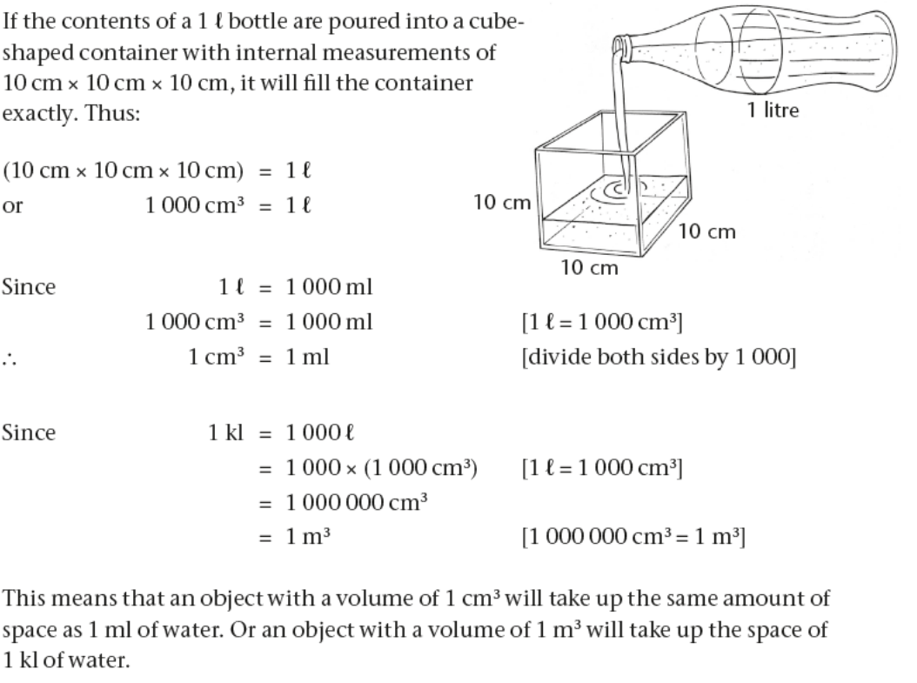

Examples:

1. Write the following volumes in $ml:$
$2 000 {cm}^{3}2 000 ml$

$2,5 l2 500 ml$

$1 l1 000 ml$

2. Write the following volumes in $kl:$
$6 500 m^{3}6 500 kl$

$20 l0,02 kl$

$1 423 000 {cm}^{3}1,423 kl$

3. A glass can hold up to $250 ml$ of water. What is the capacity of the glass:
4. in $ml$? $250 ml$
5. in ${cm}^{3}$? $250 {cm}^{3}$
6. A glass tank has the following inside measurements: length $=250 mm$, breadth $=120 mm$ and height $=100 mm$. Calculate the capacity of the tank in millilitres.

Solution:

Capacity $=250 mm×120 mm×100 mm$

$=3 000 000 {mm}^{3}$

Divide by $1 000$

$$=3000 {cm}^{3}$$

$$=3000 ml$$

Or

Capacity $=250 mm×120 mm×100 mm$

$$=25 cm×12 cm×10 cm$$

$$=3000 {cm}^{3}$$

$$=3000 ml$$