**AFRIKAANS F.A.L**

**GRAAD 6**

**WEEK 2**

**LOCKDOWN 2020**

|  |  |
| --- | --- |
| DAG 1 | * Today you have to concentrate really well. We are doing language today. You need to read through the language pages for auxiliary verbs, types of sentences, prepositions and pronouns. The rules are really simple if you pay attention to it. * Now do the language activity to practise these language skills. Read carefully and pay attention to the instructions given. |
| DAG 2 | * Today we focus on spelling and speaking. You need to find the English meanings for the new themes words. We are looking at farm animals. Use your dictionary to find the correct words. * Speaking: say the numbers out loud in Afrikaans. When you get to 20-100 go through them as well, using the examples given. * Now read the opposites out loud and make sure you remember them well. * Now do the activity, where you count the amount of farm animals and fill in the correct number or animals in each sentence. * Do the opposites worksheet where you draw a colourful line between the correct opposites. |
| DAG 3 | * Read the story about the “Drie bokkies.” It is the story of the three Billy Goats Gruff. Make sure you know and understand all the difficult words. * Now complete the comprehension questions about the work. Remember to take your time and make sure you understand what each question expects of you. Also use the story to find most of the answers. |
| DAG 4 | * Today you will need to concentrate on the language pages about parts of speech. These are the small parts of a sentence that make sentences make sense. You need to know the Afrikaans names of these parts of speech to be able to understand the worksheets. * Now do the language activities that helps you to practise these new rules. Remember to try your best, even if it seems difficult. |
| DAG 5 | * It is time to end off the week with some creative writing. Go through the notes showing how the format of a postcard looks. Ask your parents to show or explain it to you. * Now create your own postcard for your family. You are visiting the farm and you send a postcard home, giving a short description of how your day/week has been so far. Write your planning and make sure you wrote in the correct Afrikaans manner, before doing it on the page. Good luck and have fun!! |

**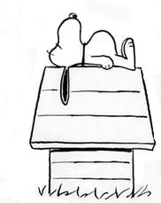DATUM:**

**TEMA: GOEIE NUUS IN DIE KOERANT**

**TAALLEER: TAALSTRUKTURE**

**A) HULPWERKWOORDE (Auxiliary verbs)**

**Definisie (definition):**

Werkwoorde wat die sinstrukture aanhelp tydens die toekomende tyd.

(The verbs helping in the sentence structure of sentences in the future tense.)

**Reëls (rules):**

1. Die werkwoord skyf na die einde van die sin.

(The verb moves to the end of the sentence.)

2. Die hulpwerkwoord word in die spasie geskryf waar die eerste werkwoord was.

(The auxiliary verb is written in the space left by the first verb.)

**C:\Users\STAFF\AppData\Local\Microsoft\Windows\Temporary Internet Files\Content.IE5\DSTR9FKQ\MC900355145[1].wmf**

**Byvoorbeeld:**

Thabo skryf ‘n brief. (wil)

Thabo wil ‘n brief skryf.

**Ander hulpwerkwoorde:**

Moet - must

Kan - can

Sal - shall

Is - is / are / am

\*\*\*\*\*\*\*\*\*\*\*\*\*\*\*\*\*\*\*\*\*\*\*\*\*\*\*\*\*\*\*\*\*\*\*\*\*\*\*\*\*\*\*\*\*\*\*\*\*\*\*\*\*\*\*\*\*\*\*\*\*\*\*\*\*\*\*\*\*\*\*\*\*\*\*\*\*\*\*\*\*\*\*\*\*\*\*\*\*\*\*\*\*\*\*\*\*\*\*\*\*\*\*\*\*\*

**B) VOORNAAMWOORDE (Pronouns):**

**Definisie**:

Wanneer jy die eienaam in die sin vervang met ‘n voornaamwoord.

(When you replace a proper noun with a pronoun.)

**Byvoorbeeld:**

Sarah speel netbal en Sarah speel ook hokkie.

Sy speel netball en sy speel ook hokkie.

**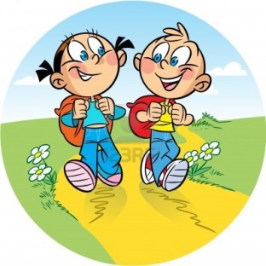**

**Ander voornaamwoorde:**

Hy - he

Syne - his (possessive)

Sy - his

Haar - her

Hare - hers

Sy - she

Ek - I

My - my

Myne - mine

\*\*\*\*\*\*\*\*\*\*\*\*\*\*\*\*\*\*\*\*\*\*\*\*\*\*\*\*\*\*\*\*\*\*\*\*\*\*\*\*\*\*\*\*\*\*\*\*\*\*\*\*\*\*\*\*\*\*\*\*\*\*\*\*\*\*\*\*\*\*\*\*\*\*\*\*\*\*\*\*\*\*\*\*\*\*\*\*\*\*\*\*\*\*\*\*\*\*\*\*\*\*\*\*\*\*\*\*\*\*\*\*

**C) TIPE SINNE (Types of sentences):**

**Definisie:**

Daar is drie soorte sinne wat ons in Afrikaans gebruik.

(There are three types of sentences in Afrikaans.)

**1. Die stelsin (The statement)**

Begin met ‘n hoofletter en eindig altyd met ‘n punt. Maak ‘n stelling.

(Starts with a capital letter and ends in a full stop. Makes a statement.)

**Byvoorbeeld:**

Ek is lekker moeg.

**2. Die vraagsin. (The question)**

Begin met ‘n hoofletter en eindig met ‘n vraagteken. Dit vra ‘n vraag.

(Starts with a capital letter and ends in a question mark. It asks a question.)

**Byvoorbeeld:**

Wat maak jy daar?

**3. Die uitroepsin (The exclamation)**

Begin met ‘n hoofletter en eindig in ‘n uitroepsin. Dit word gebruik wanneer jy skreeu of ‘n bevel gee.

(Starts with a capital letter and ends in an exclamation mark. Used when screaming or commanding)

**Byvoorbeeld:**

Stop dit dadelik!

**C:\Users\STAFF\AppData\Local\Microsoft\Windows\Temporary Internet Files\Content.IE5\DSTR9FKQ\MC900355145[1].wmf**\*\*\*\*\*\*\*\*\*\*\*\*\*\*\*\*\*\*\*\*\*\*\*\*\*\*\*\*\*\*\*\*\*\*\*\*\*\*\*\*\*\*\*\*\*\*\*\*\*\*\*\*\*\*\*\*\*\*\*\*\*\*\*\*\*\*\*\*\*\*\*\*\*\*\*\*\*\*\*\*\*\*\*\*\*\*\*\*\*\*\*\*\*\*\*\*\*\*\*\*\*\*\*\*\*\*\*\*\*

**D) VOORSETSELS (Prepositions)**

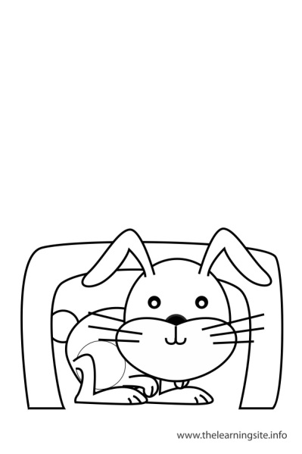**Definisie:**

Dit is die woorde in Afrikaans wat rigting of tyd aanwys.

(The words in Afrikaans that show time or direction.)

1. onder (under) 2. op (on/up) 3. agter (behind)

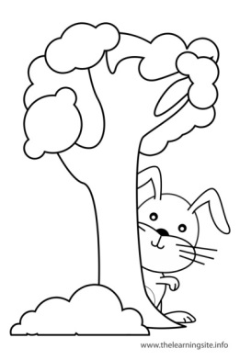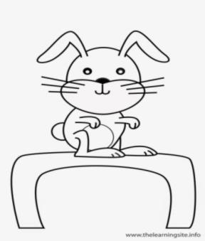

4. voor (in front of) 5. langs (next to) 6. tussen in (in between)

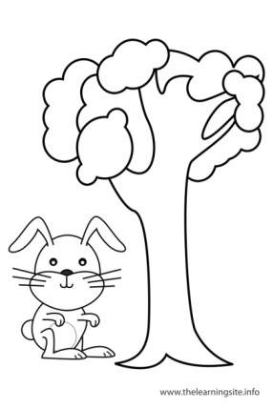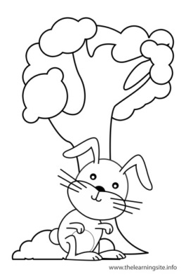

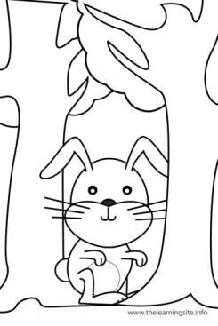

7. op (onto) 8. af (off) 9. in (in / inside)

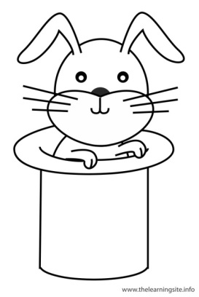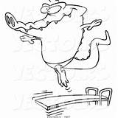

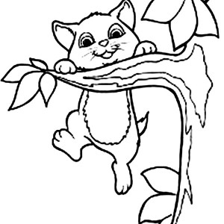

10. om (around) 11. oor (over) 12. oorkant (across/other side)

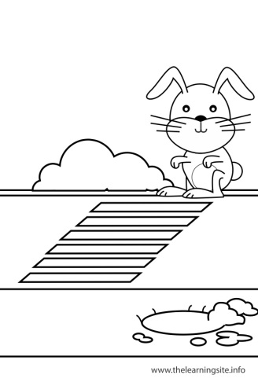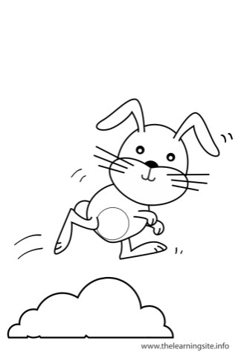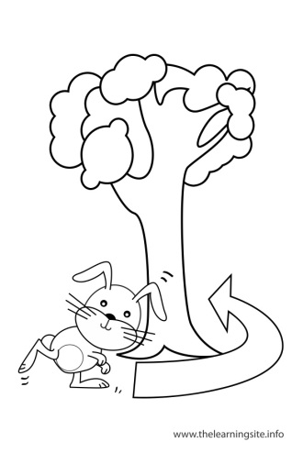

13. Uit (out) 14. Met (with) 15. Deur (through)

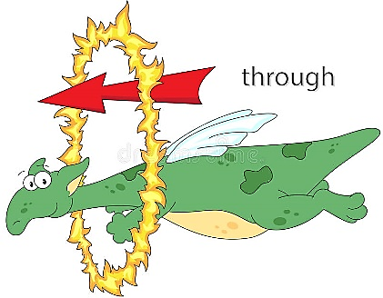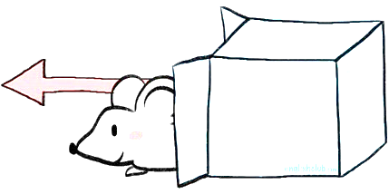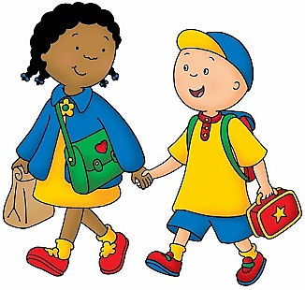

16. By (at)

\*\*\*\*\*\*\*\*\*\*\*\*\*\*\*\*\*\*\*\*\*\*\*\*\*\*\*\*\*\*\*\*\*\*\*\*\*\*\*\*\*\*\*\*\*\*\*\*\*\*\*\*\*\*\*\*\*\*\*\*\*\*\*\*\*\*\*\*\*\*\*\*\*\*\*\*\*\*\*\*\*\*\*\*\*\*\*\*\*\*\*\*\*\*\*\*\*\*\*\*\*\*\*\*\*\*\*\*\*\*\*\*

**C:\Users\STAFF\AppData\Local\Microsoft\Windows\Temporary Internet Files\Content.IE5\FEHYKZQ0\MC900434587[1].wmfDATUM:**

**TEMA: GOEIE NUUS IN DIE KOERANT**

**TAALOEFENING (LANGUAGE ACTIVITY)**

**Vraag 1**

**Voornaamwoorde**

**Vul die regte voornaamwoorde in vir elke sin gegee. (Give the pronouns)**

1.1 Emile werk in die winkel en \_\_\_\_\_\_\_\_\_\_\_\_\_verdien \_\_\_\_\_\_\_\_\_\_\_\_\_\_geld.

1.2 Emma verloor \_\_\_\_\_\_\_\_\_\_\_\_\_\_\_\_\_\_geld en dit maak \_\_\_\_\_\_\_\_\_\_\_\_\_\_\_\_\_\_kwaad.

1.3 \_\_\_\_\_\_\_\_\_\_\_\_\_\_\_\_\_kry weer sy geld by die taxibestuurder.

**Vraag 2**

**Tipe sinne**

**Benoem die tipe sinne hier gegee. (Name the types of sentences)**

2.1 Jy moet dadelik ophou! \_\_\_\_\_\_\_\_\_\_\_\_\_\_\_\_\_\_\_\_\_\_\_\_\_\_\_\_\_\_\_\_\_\_

2.2 Wat ‘n lekker dag. \_\_\_\_\_\_\_\_\_\_\_\_\_\_\_\_\_\_\_\_\_\_\_\_\_\_\_\_\_\_\_\_\_\_\_\_\_\_

2.3 Waar is Emile se beursie? \_\_\_\_\_\_\_\_\_\_\_\_\_\_\_\_\_\_\_\_\_\_\_\_\_\_\_\_\_\_\_\_\_\_\_\_

**Vraag 3**

**Hulpwerkwoorde**

**Herskryf die volgende sinne deur die hulpwerkwoord in te voeg. (Rewrite sentence using verbs given)**

3.1 Emile sê vir Daniel dankie. (wil)

\_\_\_\_\_\_\_\_\_\_\_\_\_\_\_\_\_\_\_\_\_\_\_\_\_\_\_\_\_\_\_\_\_\_\_\_\_\_\_\_\_\_\_\_\_\_\_\_\_\_\_\_\_\_\_\_\_\_\_\_\_\_\_\_\_\_\_\_\_\_\_\_\_\_\_\_\_\_

**C:\Users\STAFF\AppData\Local\Microsoft\Windows\Temporary Internet Files\Content.IE5\DSTR9FKQ\MC900355145[1].wmf**\_\_\_\_\_\_\_\_\_\_\_\_\_\_\_\_\_\_\_\_\_\_\_\_\_\_\_\_\_\_\_\_\_\_\_\_\_\_\_\_\_\_\_\_\_\_\_\_\_\_\_\_\_\_\_\_\_\_\_\_\_\_\_\_\_\_\_\_\_\_\_\_\_\_\_\_\_

3.2 Emile skryf sy adres. (sal)

\_\_\_\_\_\_\_\_\_\_\_\_\_\_\_\_\_\_\_\_\_\_\_\_\_\_\_\_\_\_\_\_\_\_\_\_\_\_\_\_\_\_\_\_\_\_\_\_\_\_\_\_\_\_\_\_\_\_\_\_\_\_\_\_\_\_\_\_\_\_\_\_\_\_\_\_\_\_

\_\_\_\_\_\_\_\_\_\_\_\_\_\_\_\_\_\_\_\_\_\_\_\_\_\_\_\_\_\_\_\_\_\_\_\_\_\_\_\_\_\_\_\_\_\_\_\_\_\_\_\_\_\_\_\_\_\_\_\_\_\_\_\_\_\_\_\_\_\_\_\_\_\_\_\_\_

3.3 Emile skryf die datum. (kan)

\_\_\_\_\_\_\_\_\_\_\_\_\_\_\_\_\_\_\_\_\_\_\_\_\_\_\_\_\_\_\_\_\_\_\_\_\_\_\_\_\_\_\_\_\_\_\_\_\_\_\_\_\_\_\_\_\_\_\_\_\_\_\_\_\_\_\_\_\_\_\_\_\_\_\_\_\_\_

\_\_\_\_\_\_\_\_\_\_\_\_\_\_\_\_\_\_\_\_\_\_\_\_\_\_\_\_\_\_\_\_\_\_\_\_\_\_\_\_\_\_\_\_\_\_\_\_\_\_\_\_\_\_\_\_\_\_\_\_\_\_\_\_\_\_\_\_\_\_\_\_\_\_\_\_\_

3.4 Emile skryf Daniel se naam. (moet)

\_\_\_\_\_\_\_\_\_\_\_\_\_\_\_\_\_\_\_\_\_\_\_\_\_\_\_\_\_\_\_\_\_\_\_\_\_\_\_\_\_\_\_\_\_\_\_\_\_\_\_\_\_\_\_\_\_\_\_\_\_\_\_\_\_\_\_\_\_\_\_\_\_\_\_\_\_\_

\_\_\_\_\_\_\_\_\_\_\_\_\_\_\_\_\_\_\_\_\_\_\_\_\_\_\_\_\_\_\_\_\_\_\_\_\_\_\_\_\_\_\_\_\_\_\_\_\_\_\_\_\_\_\_\_\_\_\_\_\_\_\_\_\_\_\_\_\_\_\_\_\_\_\_\_\_

**Vraag 4**

**Voorsetsels**

**C:\Users\STAFF\AppData\Local\Microsoft\Windows\Temporary Internet Files\Content.IE5\JBE8DV2C\MC900434605[1].wmfKyk na die prentjies gegee en voltooi dan die sinne deur die korrekte voorsetsels in die sinne in te pas.**

**(Look at the pictures given and fill the correct preposition in for each sentence.)**

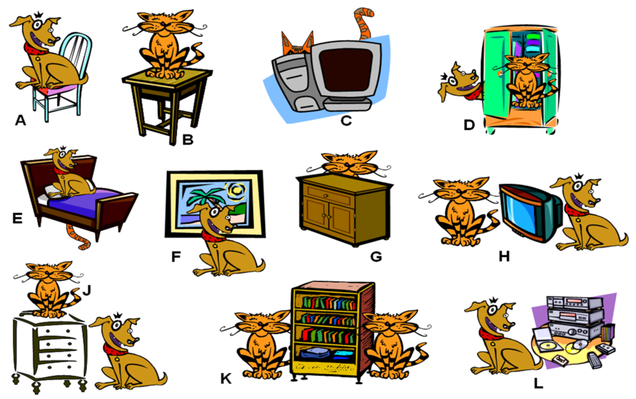

4.1 A) Die hond sit \_\_\_\_\_\_\_\_\_\_\_\_\_\_\_\_\_\_\_\_\_\_ die stoel.

4.2 C) Die kat is \_\_\_\_\_\_\_\_\_\_\_\_\_\_\_\_\_\_\_\_\_\_\_\_\_die televisie.

4.3 E) Die hond sit op die bed en die kat lê \_\_\_\_\_\_\_\_\_\_\_\_\_\_\_\_\_\_\_\_\_\_\_\_ die bed.

4.4 J) Die kat sit bo-op die bedkassie en die hond sit \_\_\_\_\_\_\_\_\_\_\_\_\_\_\_\_\_\_\_\_ die bedkassie.

4.5 K) Die boekrak staan \_\_\_\_\_\_\_\_\_\_\_\_\_\_\_\_\_\_\_\_\_\_\_\_\_\_\_\_\_ die twee katte.

**Vraag 5**

**Teenoorgesteldes (antonieme)**

**Gee die teenoorgestelde betekenis vir die volgende woorde in donker gedruk.**

**(Give the opposites for the words in bold print.)**

5.1 Die taxibestuurder het ‘n **klein** motor. \_\_\_\_\_\_\_\_\_\_\_\_\_\_\_\_\_\_\_\_\_\_\_\_\_\_\_\_\_\_\_

5.2 Emile sit **agter** in die bakkie. \_\_\_\_\_\_\_\_\_\_\_\_\_\_\_\_\_\_\_\_\_\_\_\_\_\_\_\_\_\_\_

**C:\Users\STAFF\AppData\Local\Microsoft\Windows\Temporary Internet Files\Content.IE5\DSTR9FKQ\MC900438199[1].wmf**5.3 Die geld was **baie.** \_\_\_\_\_\_\_\_\_\_\_\_\_\_\_\_\_\_\_\_\_\_\_\_\_\_\_\_\_\_\_

**DATUM:**

**TEMA: HOEVEEL DIERE IS DAAR**

**SPELLING.**

**KRY DIE ENGELSE BETEKENISSE VAN DIE VOLGENDE WOORDE:**

1. Plaas - \_\_\_\_\_\_\_\_\_\_\_\_\_\_\_\_\_\_\_\_\_\_\_\_\_\_\_\_\_\_\_\_\_\_\_\_\_\_\_\_\_\_\_\_\_\_\_\_\_

2. trekker - \_\_\_\_\_\_\_\_\_\_\_\_\_\_\_\_\_\_\_\_\_\_\_\_\_\_\_\_\_\_\_\_\_\_\_\_\_\_\_\_\_\_\_\_\_\_\_\_\_

3. stal - \_\_\_\_\_\_\_\_\_\_\_\_\_\_\_\_\_\_\_\_\_\_\_\_\_\_\_\_\_\_\_\_\_\_\_\_\_\_\_\_\_\_\_\_\_\_\_\_\_

4. bok - \_\_\_\_\_\_\_\_\_\_\_\_\_\_\_\_\_\_\_\_\_\_\_\_\_\_\_\_\_\_\_\_\_\_\_\_\_\_\_\_\_\_\_\_\_\_\_\_\_

5. skaap - \_\_\_\_\_\_\_\_\_\_\_\_\_\_\_\_\_\_\_\_\_\_\_\_\_\_\_\_\_\_\_\_\_\_\_\_\_\_\_\_\_\_\_\_\_\_\_\_\_

6. vark - \_\_\_\_\_\_\_\_\_\_\_\_\_\_\_\_\_\_\_\_\_\_\_\_\_\_\_\_\_\_\_\_\_\_\_\_\_\_\_\_\_\_\_\_\_\_\_\_\_

7. donkie - \_\_\_\_\_\_\_\_\_\_\_\_\_\_\_\_\_\_\_\_\_\_\_\_\_\_\_\_\_\_\_\_\_\_\_\_\_\_\_\_\_\_\_\_\_\_\_\_\_

8. koeie - \_\_\_\_\_\_\_\_\_\_\_\_\_\_\_\_\_\_\_\_\_\_\_\_\_\_\_\_\_\_\_\_\_\_\_\_\_\_\_\_\_\_\_\_\_\_\_\_\_

9. bul - \_\_\_\_\_\_\_\_\_\_\_\_\_\_\_\_\_\_\_\_\_\_\_\_\_\_\_\_\_\_\_\_\_\_\_\_\_\_\_\_\_\_\_\_\_\_\_\_\_

10. eende - \_\_\_\_\_\_\_\_\_\_\_\_\_\_\_\_\_\_\_\_\_\_\_\_\_\_\_\_\_\_\_\_\_\_\_\_\_\_\_\_\_\_\_\_\_\_\_\_\_

11. ganse - \_\_\_\_\_\_\_\_\_\_\_\_\_\_\_\_\_\_\_\_\_\_\_\_\_\_\_\_\_\_\_\_\_\_\_\_\_\_\_\_\_\_\_\_\_\_\_\_\_

12. haan - \_\_\_\_\_\_\_\_\_\_\_\_\_\_\_\_\_\_\_\_\_\_\_\_\_\_\_\_\_\_\_\_\_\_\_\_\_\_\_\_\_\_\_\_\_\_\_\_\_

13. hen - \_\_\_\_\_\_\_\_\_\_\_\_\_\_\_\_\_\_\_\_\_\_\_\_\_\_\_\_\_\_\_\_\_\_\_\_\_\_\_\_\_\_\_\_\_\_\_\_\_

14. hoenders - \_\_\_\_\_\_\_\_\_\_\_\_\_\_\_\_\_\_\_\_\_\_\_\_\_\_\_\_\_\_\_\_\_\_\_\_\_\_\_\_\_\_\_\_\_\_\_\_\_

15. perde - \_\_\_\_\_\_\_\_\_\_\_\_\_\_\_\_\_\_\_\_\_\_\_\_\_\_\_\_\_\_\_\_\_\_\_\_\_\_\_\_\_\_\_\_\_\_\_\_\_

16. plaasdam - \_\_\_\_\_\_\_\_\_\_\_\_\_\_\_\_\_\_\_\_\_\_\_\_\_\_\_\_\_\_\_\_\_\_\_\_\_\_\_\_\_\_\_\_\_\_\_\_\_

17. plaasdiere - \_\_\_\_\_\_\_\_\_\_\_\_\_\_\_\_\_\_\_\_\_\_\_\_\_\_\_\_\_\_\_\_\_\_\_\_\_\_\_\_\_\_\_\_\_\_\_\_\_

18. plaaswerf - \_\_\_\_\_\_\_\_\_\_\_\_\_\_\_\_\_\_\_\_\_\_\_\_\_\_\_\_\_\_\_\_\_\_\_\_\_\_\_\_\_\_\_\_\_\_\_\_\_

19. boer - \_\_\_\_\_\_\_\_\_\_\_\_\_\_\_\_\_\_\_\_\_\_\_\_\_\_\_\_\_\_\_\_\_\_\_\_\_\_\_\_\_\_\_\_\_\_\_\_\_

20. diere - \_\_\_\_\_\_\_\_\_\_\_\_\_\_\_\_\_\_\_\_\_\_\_\_\_\_\_\_\_\_\_\_\_\_\_\_\_\_\_\_\_\_\_\_\_\_\_\_\_

C:\Users\STAFF\AppData\Local\Microsoft\Windows\Temporary Internet Files\Content.IE5\JBE8DV2C\MC900030474[1].wmfC:\Users\STAFF\AppData\Local\Microsoft\Windows\Temporary Internet Files\Content.IE5\FEHYKZQ0\MC900297217[1].wmfC:\Users\STAFF\AppData\Local\Microsoft\Windows\Temporary Internet Files\Content.IE5\DSTR9FKQ\MC900233188[1].wmfC:\Users\STAFF\AppData\Local\Microsoft\Windows\Temporary Internet Files\Content.IE5\JBE8DV2C\MC900030435[1].wmfC:\Users\STAFF\AppData\Local\Microsoft\Windows\Temporary Internet Files\Content.IE5\JBE8DV2C\MC900038516[1].wmf

**C:\Users\STAFF\AppData\Local\Microsoft\Windows\Temporary Internet Files\Content.IE5\JBE8DV2C\MC900130271[1].wmfDATUM:**

**TEMA: HOEVEEL DIERE IS DAAR**

**TELWOORDE**

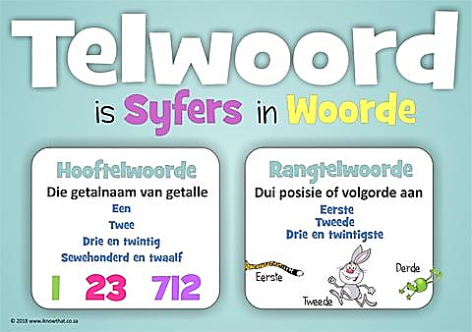

**SHOWS SHOWS**

**NUMBERS PLACE**

**VALUE**

**HOOFTELWOORDE: (COUNTING)**

**1. EEN 2. TWEE 3. DRIE 4. VIER 5. VYF**

**6. SES 7. SEWE 8. AGT 9. NEGE 10. TIEN**

**11. ELF 12. TWAALF 13. DERTIEN 14. VEERTIEN**

**15. VYFTIEN 16. SESTIEN 17. SEWENTIEN 18. AGTTIEN**

**19. NEGENTIEN 20. TWINTIG**

**21. EEN-EN-TWINTIG 22. TWEE-EN-TWINTIG 23. DRIE-EN-TWINTIG**

**24. VIER-EN-TWINTIG 25. VYF-EN-TWINTIG 26. SES-EN-TWINTIG**

**27. SEWE-EN-TWINTIG 28. AGT-EN-TWINTIG 29. NEGE-EN-TWINTIG**

**30. DERTIG 40. VEERTIG 50. VYFTIG 60. SESTIG**

**70. SEWENTIG 80. TAGTIG 90. NEGENTIG**

**100. EEN HONDERD 101. EEN HONDERD-EN-EEN**

**1000. EEN DUISEND 1001. EEN DUISEND-EN-EEN**

**BAIE – A LOT MEER – MORE MINDER – LESS**

**C:\Users\STAFF\AppData\Local\Microsoft\Windows\Temporary Internet Files\Content.IE5\JBE8DV2C\MC900441936[1].wmf**

**RANGTELWOORDE: (PLACE VALUE)**

**EERSTE -FIRST TWEEDE -SECOND**

**DERDE -THIRD VIERDE -FOURTH**

**VYFDE -FIFTH SESDE -SIXTH**

**SEWENDE -SEVENTH AGTSTE -EIGHT**

**NEGENDE -NINTH TIENDE -TENTH**

**LAASTE -LAST MIDDELSTE -MIDDLE**

**DATUM:**

**Teenoorgesteldes / antonieme (opposites)**

|  |  |
| --- | --- |
| C:\Users\STAFF\AppData\Local\Microsoft\Windows\Temporary Internet Files\Content.IE5\2GD7QLAW\5223898955_5863598312_z[1].jpg | C:\Users\STAFF\AppData\Local\Microsoft\Windows\Temporary Internet Files\Content.IE5\5RBBDTEH\thumb-Witch-Face-Cartoon-66.6-17045[1].gif |
| **mooi** | **lelik** |

|  |  |
| --- | --- |
| C:\Users\STAFF\AppData\Local\Microsoft\Windows\Temporary Internet Files\Content.IE5\5RBBDTEH\kids_jumping_rope[1].gif | C:\Users\STAFF\AppData\Local\Microsoft\Windows\Temporary Internet Files\Content.IE5\QZATC20A\lazy_person[1].jpg |
| **fluks** | C:\Users\STAFF\AppData\Local\Microsoft\Windows\Temporary Internet Files\Content.IE5\QZATC20A\sécher%20lains[1].gif**lui** |

|  |  |
| --- | --- |
| C:\Users\STAFF\AppData\Local\Microsoft\Windows\Temporary Internet Files\Content.IE5\5RBBDTEH\large-Lemonade-glass-33.3-11249[1].gif | C:\Users\STAFF\AppData\Local\Microsoft\Windows\Temporary Internet Files\Content.IE5\QZATC20A\over_a_cup_of_coffee[1].jpg |
| **koud** | **warm** |

|  |  |
| --- | --- |
| C:\Users\STAFF\AppData\Local\Microsoft\Windows\Temporary Internet Files\Content.IE5\5RBBDTEH\chair[1].png | C:\Users\STAFF\AppData\Local\Microsoft\Windows\Temporary Internet Files\Content.IE5\QZATC20A\armchair[1].png |
| **hard** | **sag** |

|  |  |
| --- | --- |
|  | C:\Users\STAFF\AppData\Local\Microsoft\Windows\Temporary Internet Files\Content.IE5\2GD7QLAW\drawing_101___towel_study_2_by_xycolsen[1].jpg |
| **nat** | **droog** |

|  |  |
| --- | --- |
| C:\Users\STAFF\AppData\Local\Microsoft\Windows\Temporary Internet Files\Content.IE5\QZATC20A\glass-of-orange-juice[1].jpg | C:\Users\STAFF\AppData\Local\Microsoft\Windows\Temporary Internet Files\Content.IE5\D5G3FSRI\large-Glass-Jar-166.6-4482[1].gif |
| **vol** | **leeg** |

|  |  |
| --- | --- |
| C:\Users\STAFF\AppData\Local\Microsoft\Windows\Temporary Internet Files\Content.IE5\5RBBDTEH\large-arrow-pointing-left-circular-icon-button-166.6-16023[1].gif | 12+ Clipart Hands - Cli... Clipart Of Hands | ClipartLook |
| **links** | **regs** |

|  |  |
| --- | --- |
| C:\Users\STAFF\AppData\Local\Microsoft\Windows\Temporary Internet Files\Content.IE5\QZATC20A\1950s-Vintage-Dress[1].png | C:\Users\STAFF\AppData\Local\Microsoft\Windows\Temporary Internet Files\Content.IE5\2GD7QLAW\poor%20girl[1].gif |
| **nuut** | **oud** |

|  |  |
| --- | --- |
| C:\Users\STAFF\AppData\Local\Microsoft\Windows\Temporary Internet Files\Content.IE5\D5G3FSRI\standing-at-the-table[1].png | C:\Users\STAFF\AppData\Local\Microsoft\Windows\Temporary Internet Files\Content.IE5\QZATC20A\PngMedium-Baby-girl-sitting-11929[1].gif |
| **hoog** | **laag** |

|  |  |
| --- | --- |
| C:\Users\STAFF\AppData\Local\Microsoft\Windows\Temporary Internet Files\Content.IE5\5RBBDTEH\sad_eyed_scootaloo_by_creshosk-d421jm1[1].png | C:\Users\STAFF\AppData\Local\Microsoft\Windows\Temporary Internet Files\Content.IE5\2GD7QLAW\happy_dashie_by_liamwhite1-d7qdrwu[1].png |
| **ongelukkig** | **gelukkig** |



|  |  |
| --- | --- |
| C:\Users\STAFF\AppData\Local\Microsoft\Windows\Temporary Internet Files\Content.IE5\D5G3FSRI\cat[1].jpg | C:\Users\STAFF\AppData\Local\Microsoft\Windows\Temporary Internet Files\Content.IE5\2GD7QLAW\cat-clip-art-fat-cat[1].gif |
| **maer** | **vet** |



|  |  |
| --- | --- |
|  |  |
| **sterk** | **swak** |

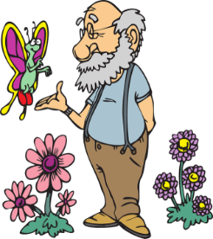



|  |  |
| --- | --- |
|  |  |
| **oud** | **jonk** |

|  |  |
| --- | --- |
| C:\Users\STAFF\AppData\Local\Microsoft\Windows\Temporary Internet Files\Content.IE5\5RBBDTEH\pencil-14082-large[1].png | C:\Users\STAFF\AppData\Local\Microsoft\Windows\Temporary Internet Files\Content.IE5\QZATC20A\large-Pencil-66.6-2963[1].gif |
| **lank** | **kort** |

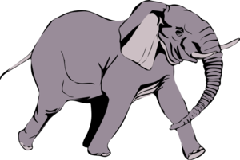

|  |  |
| --- | --- |
|  |  |
| **groot** | **klein** |



|  |  |
| --- | --- |
| **skoon** | **vuil** |
|  |  |



|  |  |
| --- | --- |
| **skoon** | **vuil** |

**DATUM:**

**HOEVEEL DIERE IS DAAR?**

Kyk na die prentjie gegee en beantwoord die vrae wat volg: Jy gaan die getal neerskryf vir die diere in elke sin, of jy gaan die diere neerskryf vir elke sin. Lees jou sinne mooi.

(Look at the picture and give the correct Afrikaans number or the name of the animal for each sentence.)

|  |
| --- |
| https://images-na.ssl-images-amazon.com/images/I/81VcvfO8XtL._AC_SL1500_.jpg |

1. Op die plaas is daar \_\_\_\_\_\_\_\_\_\_\_\_\_\_\_\_\_\_\_\_\_\_\_\_\_\_\_ varke.

2. Daar is \_\_\_\_\_\_\_\_\_\_\_\_\_\_\_\_\_\_\_\_\_\_ perde in die werf.

3. Daar is \_\_\_\_\_\_\_\_\_\_\_\_\_\_\_\_\_\_\_\_\_\_\_\_\_\_\_\_\_\_\_\_\_skape wat wei in die veld.

4. Die een \_\_\_\_\_\_\_\_\_\_\_\_\_\_\_\_\_\_\_\_\_\_\_\_\_\_\_\_ jaag die hoenders rond.

5. Daar is \_\_\_\_\_\_\_\_\_\_\_\_\_\_\_\_\_\_\_\_\_koei, \_\_\_\_\_\_\_\_\_\_\_\_\_\_\_\_\_\_\_\_ katte in die skuur en

MC900417432[1]

agt \_\_\_\_\_\_\_\_\_\_\_\_\_\_\_\_\_\_\_\_\_ op die plaas.

6. Daar is \_\_\_\_\_\_\_\_\_\_\_\_\_\_\_\_\_\_\_\_\_\_\_\_\_voëls wat op die plaas rondvlieg.

**Datum:**

**Teenoorgestelde oefening.**

**Trek ‘n streep vanaf kolom A na kolom B, om te wys wat die teenoorgesteldes van elke werk is.**

|  |  |  |
| --- | --- | --- |
| **Kolom A** | **Antwoorde** | **Kolom B** |
| Guardian Angel Cliparts, Stock Vector And Royalty Free Guardian ...  1. |  | C:\Users\STAFF\AppData\Local\Microsoft\Windows\Temporary Internet Files\Content.IE5\3EY6I469\MC900423165[1].wmf  a. |
| Cat Sleeping Stock Illustrations – 6,093 Cat Sleeping Stock ...  2. | Face expression cute little girl smiling Vector Image  b. |
| Hard Bed Clipart  3. | sun-safety-for-kids-227x300 - Slater Vecchio  c. |
| 8+ Desert Clip Art... Desert Clipart | ClipartLook  4. | Black Old Woman With Hip Pain Cartoon Vector Clipart - FriendlyStock  d. |
| C:\Users\STAFF\AppData\Local\Microsoft\Windows\Temporary Internet Files\Content.IE5\3EY6I469\MC900423171[1].wmf  5. | Halloween Clipart Devil Png Royalty Free Ch B *✿* - Halloween ...  e. |
| Time Of Day Illustrations, Royalty-Free Vector Graphics & Clip Art ...  6. | Hard Bed Clipart  f. |
| Illustration Featuring A Hot Cup Of Tea Stock Photo, Picture And ...  7. | 17+ The Forest Path Ve... Forest Clipart | ClipartLook  g. |
| Angry Rain Wet Stock Illustrations – 40 Angry Rain Wet Stock ...  8. | 26,532 Cat Clipart Stock Illustrations, Cliparts And Royalty Free ...  h. |
| Black Old Guy With Walking Stick Cartoon Vector Clipart ...  9. | Time Of Day Illustrations, Royalty-Free Vector Graphics & Clip Art ...  i. |
| Boy Cartoon png download - 794*859 - Free Transparent Face png ...  10. | Cold Drink Clipart  j. |

**DATUM:**

**BEGRIPSTOETS BL 32-34**

**Lees die storie oor die drie bokkies en beantwoord dan die vrae wat volg.**

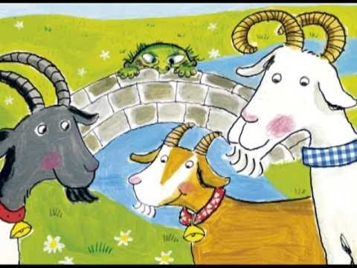**Die drie bokkies**

Eenmaal was daar drie bokkies. Hulle name was Groot Bok, Kleiner Bok en Kleinste Bokkie. Hulle was al drie rammetjies. Die hele winter lank bly hulle in die berge waar daar min kos is. Toe dit lente word, is hulle baie maer en honger. Hulle kyk na die gras oorkant die rivier, anderkant die

brug. “Ons moet oorkant die rivier gaan wei waar die gras groen en sappig is,” sê Groot Bok. “Ons moet oor die brug loop!” “Maar die kwaai, ou reus wat onder die brug bly, sal ons vang! Hy laat niemand oor nie,” sê Kleinste Bokkie. “Ek is baie bang!”

Die bokkies is te bang om oor die brug te loop, maar hulle word hongerder en hongerder. Eendag kan hulle dit nie meer uithou nie. Hulle dink aan ’n plan. Kleinste Bokkie stap eerste na die brug toe. “Wie is daar?” roep die kwaai, ou reus met ’n diep stem. “Dit is net ek, Kleinste Bokkie,” antwoord hy. “Jy mag nie oor my brug stap nie. Ek sal jou opeet,” roep die kwaai, ou reus. “Maar ek is so klein en maer. Ek is net ’n mondvol,” sê Kleinste Bokkie. “As jy net ’n bietjie wag, kom my ouer boetie. Hy is nou-nou hier.” “Nou goed dan,” sê die kwaai, ou reus. Kleinste Bokkie stap veilig oor die brug.

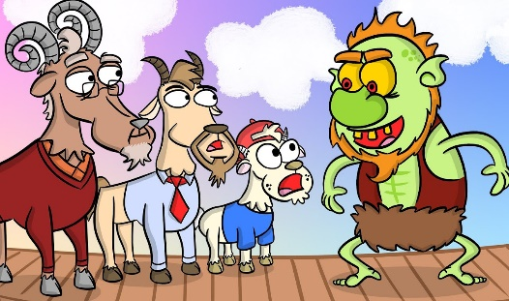

Net daarna kom Kleiner Bok by die brug. Die kwaai, ou reus spring op en gil: “Jy mag nie oor my brug stap nie. Ek sal jou opeet!” Kleiner Bok antwoord: “Ek is nie veel groter as my klein boetie nie. Ek is net twee monde vol. Wag liewer vir my oudste broer. Hy is groot. Hy sal nou-nou hier wees.” “Nou goed dan, maar ek raak nou baie honger. Ek is lus vir lekker bokvleis, h’mmm!” waarsku die kwaai, ou reus.

Kort daarna kom Groot Bok by die brug. Die kwaai, ou reus spring op en probeer hom vang. Maar Groot Bok is baie sterk. Hy stamp die kwaai, ou reus met sy yslike horings. Die reus val af ... af tot in die middel van die rivier. Groot Bok lag en lag. Hy hardloop vinnig oor die brug na sy boeties toe. Hulle is al drie veilig en wei heerlik in die groen gras.

**A. BEANTWOORD DIE VRAE**

* 1. Waar het die drie bokkies in die winter gebly?

\_\_\_\_\_\_\_\_\_\_\_\_\_\_\_\_\_\_\_\_\_\_\_\_\_\_\_\_\_\_\_\_\_\_\_\_\_\_\_\_\_\_\_\_\_\_\_\_\_\_\_\_\_\_\_\_\_\_\_\_\_\_\_\_\_\_\_\_\_\_\_\_\_\_\_

* 1. Wat is die bokkies van mekaar?

\_\_\_\_\_\_\_\_\_\_\_\_\_\_\_\_\_\_\_\_\_\_\_\_\_\_\_\_\_\_\_\_\_\_\_\_\_\_\_\_\_\_\_\_\_\_\_\_\_\_\_\_\_\_\_\_\_\_\_\_\_\_\_\_\_\_\_\_\_\_\_\_\_\_\_

* 1. Hoekom word hulle baie maer en honger?

\_\_\_\_\_\_\_\_\_\_\_\_\_\_\_\_\_\_\_\_\_\_\_\_\_\_\_\_\_\_\_\_\_\_\_\_\_\_\_\_\_\_\_\_\_\_\_\_\_\_\_\_\_\_\_\_\_\_\_\_\_\_\_\_\_\_\_\_\_\_\_\_\_\_\_

* 1. Waar is die groen gras wat hulle kan eet?

\_\_\_\_\_\_\_\_\_\_\_\_\_\_\_\_\_\_\_\_\_\_\_\_\_\_\_\_\_\_\_\_\_\_\_\_\_\_\_\_\_\_\_\_\_\_\_\_\_\_\_\_\_\_\_\_\_\_\_\_\_\_\_\_\_\_\_\_\_\_\_\_\_\_\_

* 1. Hoekom is dit gevaarlik om oor die brug te stap?

\_\_\_\_\_\_\_\_\_\_\_\_\_\_\_\_\_\_\_\_\_\_\_\_\_\_\_\_\_\_\_\_\_\_\_\_\_\_\_\_\_\_\_\_\_\_\_\_\_\_\_\_\_\_\_\_\_\_\_\_\_\_\_\_\_\_\_\_\_\_\_\_\_\_\_

* 1. Hoekom is die bokkies veilig aan die einde van die storie?

\_\_\_\_\_\_\_\_\_\_\_\_\_\_\_\_\_\_\_\_\_\_\_\_\_\_\_\_\_\_\_\_\_\_\_\_\_\_\_\_\_\_\_\_\_\_\_\_\_\_\_\_\_\_\_\_\_\_\_\_\_\_\_\_\_\_\_\_\_\_\_\_\_\_\_

## B. WAAR OF VALS

**Sê of is die sinne waar of vals. Indien vals, skryf die sinne korrek neer.**

2.1 Die bokkies bly die hele somer in die berge.

\_\_\_\_\_\_\_\_\_\_\_\_\_\_\_\_\_\_\_\_\_\_\_\_\_\_\_\_\_\_\_\_\_\_\_\_\_\_\_\_\_\_\_\_\_\_\_\_\_\_\_\_\_\_\_\_\_\_\_\_\_\_\_\_\_\_\_\_\_\_\_\_\_\_\_

\_\_\_\_\_\_\_\_\_\_\_\_\_\_\_\_\_\_\_\_\_\_\_\_\_\_\_\_\_\_\_\_\_\_\_\_\_\_\_\_\_\_\_\_\_\_\_\_\_\_\_\_\_\_\_\_\_\_\_\_\_\_\_\_\_\_\_\_\_\_\_\_\_\_\_

2.2 Die gras is aan die ander kant van die brug.

\_\_\_\_\_\_\_\_\_\_\_\_\_\_\_\_\_\_\_\_\_\_\_\_\_\_\_\_\_\_\_\_\_\_\_\_\_\_\_\_\_\_\_\_\_\_\_\_\_\_\_\_\_\_\_\_\_\_\_\_\_\_\_\_\_\_\_\_\_\_\_\_\_\_\_

\_\_\_\_\_\_\_\_\_\_\_\_\_\_\_\_\_\_\_\_\_\_\_\_\_\_\_\_\_\_\_\_\_\_\_\_\_\_\_\_\_\_\_\_\_\_\_\_\_\_\_\_\_\_\_\_\_\_\_\_\_\_\_\_\_\_\_\_\_\_\_\_\_\_\_

2.3 Daar bly ‘n vriendelike ou reus onder die brug.

\_\_\_\_\_\_\_\_\_\_\_\_\_\_\_\_\_\_\_\_\_\_\_\_\_\_\_\_\_\_\_\_\_\_\_\_\_\_\_\_\_\_\_\_\_\_\_\_\_\_\_\_\_\_\_\_\_\_\_\_\_\_\_\_\_\_\_\_\_\_\_\_\_\_\_

\_\_\_\_\_\_\_\_\_\_\_\_\_\_\_\_\_\_\_\_\_\_\_\_\_\_\_\_\_\_\_\_\_\_\_\_\_\_\_\_\_\_\_\_\_\_\_\_\_\_\_\_\_\_\_\_\_\_\_\_\_\_\_\_\_\_\_\_\_\_\_\_\_\_\_

2.4 Groot bok stamp die reus van die brug af.

\_\_\_\_\_\_\_\_\_\_\_\_\_\_\_\_\_\_\_\_\_\_\_\_\_\_\_\_\_\_\_\_\_\_\_\_\_\_\_\_\_\_\_\_\_\_\_\_\_\_\_\_\_\_\_\_\_\_\_\_\_\_\_\_\_\_\_\_\_\_\_\_\_\_\_

\_\_\_\_\_\_\_\_\_\_\_\_\_\_\_\_\_\_\_\_\_\_\_\_\_\_\_\_\_\_\_\_\_\_\_\_\_\_\_\_\_\_\_\_\_\_\_\_\_\_\_\_\_\_\_\_\_\_\_\_\_\_\_\_\_\_\_\_\_\_\_\_\_\_\_

**C. VUL DIE REGTE ANTWOORDE IN.**

**Vul die regte woorde in die spasies gelaat om die sinne te voltooi.**

|  |
| --- |
| Oor eerste gras stamp einde begin veilig reus tweede |

3.1 Aan die \_\_\_\_\_\_\_\_\_\_\_\_\_\_\_\_\_\_\_\_\_\_\_\_ van die sprokie is die bokkies honger.

3.2 Hulle sien groen \_\_\_\_\_\_\_\_\_\_\_\_\_\_\_\_\_\_\_\_\_\_aan die oorkant van die brug.

3.3 Hulle moet \_\_\_\_\_\_\_\_\_\_\_\_\_\_\_\_\_\_\_\_\_\_\_\_die brug loop om dit te kry.

MC900091065[1]

3.4 Die kwaai, ou \_\_\_\_\_\_\_\_\_\_\_\_\_\_\_\_\_\_\_\_\_\_\_\_bly onder die brug.

3.5 Kleinste bokkie stap \_\_\_\_\_\_\_\_\_\_\_\_\_\_\_\_\_\_\_\_\_\_\_\_\_\_oor die brug.

* 1. Kleiner Bok stap \_\_\_\_\_\_\_\_\_\_\_\_\_\_\_\_\_\_\_\_\_\_\_\_\_\_\_\_\_\_oor die brug.
  2. Grook Bok stap derde oor en \_\_\_\_\_\_\_\_\_\_\_\_\_\_\_\_\_\_\_\_\_\_\_\_\_\_die reus van die brug af.
  3. Aan die \_\_\_\_\_\_\_\_\_\_\_\_\_\_\_\_\_\_\_\_\_\_\_\_\_\_\_\_\_\_\_\_is die drie bokkies \_\_\_\_\_\_\_\_\_\_\_\_\_\_\_\_\_\_\_ aan die anderkant van die brug en vreet hulle gras.

**DATUM:**

MC900084280[1]**TAALLEER: SINSDELE**

**LANGUAGE: PARTS OF SPEECH**

**1. TELWOORDE:(NUMBERS/PLACE VALUES)**

**Definisie:**

Dit is woorde wat vir jou die getal of plekwaarde van iets aanwys.

(Words showing place value or numbers)

**Gebruik:**

As ons na iets verwys wat vertel hoeveel daar van iets is.

(When we show how much of things there are.)

**Voorbeeld**:

Daar is **tien** skape. - There are ten sheep

Die seun is **eerste**. - The boy was first.

MC900446182[1]**2. WERKWOORDE:(VERBS)**

**Definisie:**

Dit is die woorde wat beweging of aksie aantoon in die sin.

(Words showing movement or actions in a sentence)

**Gebruik:**

Om ‘n persoon of dier se beweging of aksie te gee.

(To give movement or action to a noun.)

**Voorbeeld:**

Die meisies **praat** baie. - The girls talk a lot.

**Lys werkwoorde:**

Praat -talk/speak Loop -walk Hardloop -run

Spring -jump Sit -sit Lag -laugh

Huil -cry Lui -ring/lazy Luister -listen/listening

Beweeg -move Lees -read Kyk -look/watch

**3. HULPWERKWOORDE: (AUXILIARY VERBS)**

**Definisie:**

Werkwoorde wat nie op hul eie kan staan nie en gewoonlik tyd aandui.

(Verbs that don’t mean anything on its own and also helps to show tenses.)

MC900445770[1]

**Gebruik:**

Word gebruik om tyd aan te dui.

(Used to show tenses.)

**Voorbeeld :**

Daar **is** die kinders. - There are the children.

**Lys van hulpwerkwoorde:**

Is - is/are/am Was - was

Kan - can Kon - could

Het - had/did Sal - shall

Moet - must Moes - should have

**4. LIDWOORDE: (Determiners)**

MC900446094[1]

# **Definisie:**

Dit is **‘n** of **die** wat saam met die selfstandige naamwoord gebruik word.

(It is when **a/an** or the is used with nouns.)

**Gebruik:**

‘n: Word gebruik wanneer daar van enige ding of mens gepraat word.

(A/an is used when referring to any thing or person.)

Die: Word gebruik wanneer daar na iets of iemand spesifiek verwys word.

(The is used when referring to a specific thing or person.)

**Voorbeeld:**

Gee asb vir my ‘n pen. - Please give me a pen.

Gee asb vir my die pen op die tafel. - Please give me the pen on the table.

**5. SELFSTANDIGE NAAMWOORDE:(NOUNS)**

MC900446182[1]**Definisie:**

Dit is enige iets wat jy kan sien, aan kan raak of kan proe.

(Things you can see, touch or taste.)

**Gebruik:**

Word in sinne gebruik om na dinge te verwys.

(Used in sentences to show what you are referring to.)

**Voorbeeld:**

Die ou **huis** is mooi. - The old house is pretty.

**Lys van selfstandige naamwoorde:**

Mens - person Tafel - table

Bal - ball Skool - school

Ma - mom Pa - dad

Motor - car Klaskamer - classroom

Diere - animals Huis - house

**5.1 EIENAAM: (PROPER NOUN)**

**Definisie:**

Verwys na die name van mense, plekke en besighede. Word altyd in hoofletters geskryf.

(Refers to the names of people, places and businesses. Always written in capital letters.)

MC900233188[1]

**Gebruik:**

Wanneer ons mense se name gebruik.

(When using the names of people and things)

**Voorbeeld:**

**Pieter** werk by **Woolworths** in **Greenstone.**

**5.2 VOORNAAMWOORDE:(PRONOUNS)**

**Definisie:**

Word gebruik wanneer ons na ‘n persoon verwys sonder om die naam die hele tyd te sê.

(Used when referring to a person,without using their names all the time.)

**Voorbeeld:**

Pieter hou van **sy** klere. - Peter likes his clothes.

**Lys van voornaamwoorde:**

MC900446094[1]

Hy - he Sy - she/his

Hulle - they Julle - them

Ons - we Ek - I

Haar - her Hom - him

**5.3 BESITLIKE VOORNAAMWOORDE:(POSSESIVE PRONOUNS)**

MC900334778[1]

**Definisie:**

Woorde wat besitting aantoon.

(Words showing possession.)

**Voorbeeld:**

Die boek is **hare**.

**Lys van besitlike voornaamwoorde:**

Sy - his Syne - his myne - mine

Hare - hers Hulle s’n - theirs Julle s’n - yours

Ons s’n - ours Haar - hers my - my

**5.4 ABSTRAKTE VOORNAAMWOORDE: (ABSTRACT NOUNS)**

**Definisie:**

Woorde wat emosie toon.

(Words that show emotions.)

**Voorbeeld:**

Sy voel baie **ongelukkig** vandag. - She feels very sad today.

MC900030435[1]

**6. BYVOEGLIKE NAAMWOORDE: (ADJECTIVES)**

**Definisie:**

Dit is woorde wat die selfstandige naamwoorde beskryf.

(Words describing the nouns in a sentence)

**Voorbeeld:**

Die **rooi** motor is vinnig. - The red car is fast.

**Lys van byvoeglike naamwoorde:**

Mooi - pretty/beautiful Sterk - strong

Vinnig - fast Stadig - slow

Lank - long/tall Slim - smart/clever

Ryk - rich Donker - dark

**DATUM:**

**TAALOEFENING**

**A) WERKWOORDE**

Skryf die volgende werkwoorde in die korrekte spasies gelaat.

(Write the verbs in the correct spaces for each sentence.)

|  |
| --- |
| Skop loop sing bak leer |

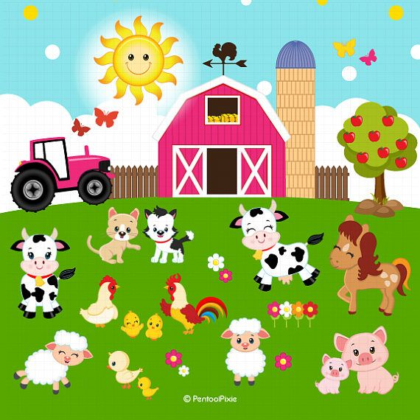

* 1. Die voëltjies \_\_\_\_\_\_\_\_\_\_\_\_\_\_\_\_\_\_\_\_\_\_\_\_\_ ‘n mooi deuntjie.
  2. Die varke \_\_\_\_\_\_\_\_\_\_\_\_\_\_\_\_\_\_\_\_\_\_\_\_\_\_\_\_\_\_\_op die plaaswerf rond.
  3. Die honde \_\_\_\_\_\_\_\_\_\_\_\_\_\_\_\_\_\_\_\_\_\_\_\_\_\_\_\_om skape te op te pas.
  4. Die perd \_\_\_\_\_\_\_\_\_\_\_\_\_\_\_\_\_\_\_\_\_\_\_\_\_\_die boer op sy been.
  5. Die boer se vrou \_\_\_\_\_\_\_\_\_\_\_\_\_\_\_\_\_\_\_\_\_\_\_\_\_\_\_\_lekker koekies.

## B) SELFSTANDIGE NAAMWOORDE

Omkring die selfstandige naamwoorde in die volgende sinne.(Circle the nouns in the following sentences)

* 1. Hoor hoe hard kraai die haan elke oggend.
  2. Die trekker maak ‘n lawaai.
  3. Die varke rol in die modder rond.

## C) BESITLIKE VOORNAAMWOORDE

Skryf die besitlike voornaamwoord neer vir elke sin.(Write down the possessive pronoun for each sentence.)

3.1 Die kat hou baie van die melk. Die melk is \_\_\_\_\_\_\_\_\_\_\_\_\_\_\_\_\_\_\_\_\_\_\_

3.2 Ons hou baie van die perde. Die perde is \_\_\_\_\_\_\_\_\_\_\_\_\_\_\_\_\_\_\_\_\_\_\_\_

3.3 Hy ry op die trekker. Die trekker is \_\_\_\_\_\_\_\_\_\_\_\_\_\_\_\_\_\_\_\_\_\_

3.4 Petra doen haar huiswerk in \_\_\_\_\_\_\_\_\_\_\_\_\_\_\_\_\_\_\_\_\_\_\_boek.



* 1. Die boer hou van \_\_\_\_\_\_\_\_\_\_\_\_\_\_\_\_\_\_\_\_\_\_\_koffie warm.

## D) BYVOEGLIKE NAAMWOORDE

Vul ‘n byvoeglike naamwoord in vir elk van die volgende sinne.

4.1 Die plaas het ‘n \_\_\_\_\_\_\_\_\_\_\_\_\_\_\_\_\_\_\_\_\_\_\_\_\_\_\_\_\_\_dam.

4.2 Die boer hou baie van sy \_\_\_\_\_\_\_\_\_\_\_\_\_\_\_\_\_\_\_\_\_\_\_\_\_\_trekker.

4.3 Die skape het lekker \_\_\_\_\_\_\_\_\_\_\_\_\_\_\_\_\_\_\_\_\_\_\_\_\_\_\_\_wol.

4.4 Die mense ry op die \_\_\_\_\_\_\_\_\_\_\_\_\_\_\_\_\_\_\_\_\_\_\_\_\_\_perde.

4.5 Die haan het \_\_\_\_\_\_\_\_\_\_\_\_\_\_\_\_\_\_\_\_\_\_\_\_\_\_\_\_\_\_vere.

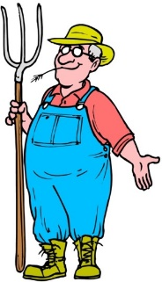**DATUM:**

**TAALOEFENINGE**

**1. HULPWERKWOORDE**

**Herskryf die sinne deur die hulpwerkwoord in die hakies te gebruik.**

**(Use the auxiliary verbs given to rewrite the sentences given.)**

* 1. Die lammetjie slaap in die warm hok. (moet)

\_\_\_\_\_\_\_\_\_\_\_\_\_\_\_\_\_\_\_\_\_\_\_\_\_\_\_\_\_\_\_\_\_\_\_\_\_\_\_\_\_\_\_\_\_\_\_\_\_\_\_\_\_\_\_\_\_\_\_\_\_\_\_\_\_\_\_\_\_\_\_\_\_\_\_

\_\_\_\_\_\_\_\_\_\_\_\_\_\_\_\_\_\_\_\_\_\_\_\_\_\_\_\_\_\_\_\_\_\_\_\_\_\_\_\_\_\_\_\_\_\_\_\_\_\_\_\_\_\_\_\_\_\_\_\_\_\_\_\_\_\_\_\_\_\_\_\_\_\_\_

* 1. Die bokram stamp met sy horings. (kan)

\_\_\_\_\_\_\_\_\_\_\_\_\_\_\_\_\_\_\_\_\_\_\_\_\_\_\_\_\_\_\_\_\_\_\_\_\_\_\_\_\_\_\_\_\_\_\_\_\_\_\_\_\_\_\_\_\_\_\_\_\_\_\_\_\_\_\_\_\_\_\_\_\_\_\_

\_\_\_\_\_\_\_\_\_\_\_\_\_\_\_\_\_\_\_\_\_\_\_\_\_\_\_\_\_\_\_\_\_\_\_\_\_\_\_\_\_\_\_\_\_\_\_\_\_\_\_\_\_\_\_\_\_\_\_\_\_\_\_\_\_\_\_\_\_\_\_\_\_\_\_

* 1. Die bokram eet die blare aan die bome. (sal)

\_\_\_\_\_\_\_\_\_\_\_\_\_\_\_\_\_\_\_\_\_\_\_\_\_\_\_\_\_\_\_\_\_\_\_\_\_\_\_\_\_\_\_\_\_\_\_\_\_\_\_\_\_\_\_\_\_\_\_\_\_\_\_\_\_\_\_\_\_\_\_\_\_\_\_

\_\_\_\_\_\_\_\_\_\_\_\_\_\_\_\_\_\_\_\_\_\_\_\_\_\_\_\_\_\_\_\_\_\_\_\_\_\_\_\_\_\_\_\_\_\_\_\_\_\_\_\_\_\_\_\_\_\_\_\_\_\_\_\_\_\_\_\_\_\_\_\_\_\_\_

MC900230063[1]

**2. MEERVOUDE EN VERKLEINWOORDE**

**Voltooi die tabel deur die meervoude of verkleinwoorde vir die woorde te gee.**

**(Complete the sentences by filling in the plurals or diminutives)**

|  |  |  |
| --- | --- | --- |
| **Woord** | **Meervoud** | **Verkleinwoord** |
| Vark | 2.1 \_\_\_\_\_\_\_\_\_\_\_\_\_\_\_\_\_\_\_ | Varkie |
| 2.2\_\_\_\_\_\_\_\_\_\_\_\_\_\_\_\_ | Koeie | Koeitjie |
| Perd | 2.3 \_\_\_\_\_\_\_\_\_\_\_\_\_\_\_\_\_\_ | 2.4\_\_\_\_\_\_\_\_\_\_\_\_\_\_\_\_\_\_\_ |
| 2.5 \_\_\_\_\_\_\_\_\_\_\_\_\_\_\_\_ | Eende | Eendjie |
| Gans | 2.6 \_\_\_\_\_\_\_\_\_\_\_\_\_\_\_\_\_ | * 1. \_\_\_\_\_\_\_\_\_\_\_\_\_\_\_\_\_\_\_ |
| Dier | Diere | 2.8\_\_\_\_\_\_\_\_\_\_\_\_\_\_\_\_\_\_\_\_ |

MC900230063[1]**3. LIDWOORDE**

**Omkring die regte lidwoord vir die sinne gegee.**

**(Circle the correct answer for each sentence)**

3.1 (‘n / Die) Koei gee vir ons elke dag melk.

3.2 (‘n / Die) bruin perd kan vinnig hardloop.

3.3 (‘n / Die) hen lê eiers.

**4. VOEGWOORDE**

**Voeg die sinne saam deur die woord in hakies te gebruik.**

**(Join the sentences by using the words given in brackets.)**

4.1 Die drie bokkies is maer en honger. Daar is min kos. (want)

\_\_\_\_\_\_\_\_\_\_\_\_\_\_\_\_\_\_\_\_\_\_\_\_\_\_\_\_\_\_\_\_\_\_\_\_\_\_\_\_\_\_\_\_\_\_\_\_\_\_\_\_\_\_\_\_\_\_\_\_\_\_\_\_\_\_\_\_\_\_\_\_\_\_\_

\_\_\_\_\_\_\_\_\_\_\_\_\_\_\_\_\_\_\_\_\_\_\_\_\_\_\_\_\_\_\_\_\_\_\_\_\_\_\_\_\_\_\_\_\_\_\_\_\_\_\_\_\_\_\_\_\_\_\_\_\_\_\_\_\_\_\_\_\_\_\_\_\_\_\_

4.2 Hulle moet oor die brug stap. Die groen gras is aan die ander kant. (omdat)

\_\_\_\_\_\_\_\_\_\_\_\_\_\_\_\_\_\_\_\_\_\_\_\_\_\_\_\_\_\_\_\_\_\_\_\_\_\_\_\_\_\_\_\_\_\_\_\_\_\_\_\_\_\_\_\_\_\_\_\_\_\_\_\_\_\_\_\_\_\_\_\_\_\_\_

\_\_\_\_\_\_\_\_\_\_\_\_\_\_\_\_\_\_\_\_\_\_\_\_\_\_\_\_\_\_\_\_\_\_\_\_\_\_\_\_\_\_\_\_\_\_\_\_\_\_\_\_\_\_\_\_\_\_\_\_\_\_\_\_\_\_\_\_\_\_\_\_\_\_\_

4.3 Die groot reus wil die bokkies opeet. Hulle is bang. (daarom)

\_\_\_\_\_\_\_\_\_\_\_\_\_\_\_\_\_\_\_\_\_\_\_\_\_\_\_\_\_\_\_\_\_\_\_\_\_\_\_\_\_\_\_\_\_\_\_\_\_\_\_\_\_\_\_\_\_\_\_\_\_\_\_\_\_\_\_\_\_\_\_\_\_\_\_

\_\_\_\_\_\_\_\_\_\_\_\_\_\_\_\_\_\_\_\_\_\_\_\_\_\_\_\_\_\_\_\_\_\_\_\_\_\_\_\_\_\_\_\_\_\_\_\_\_\_\_\_\_\_\_\_\_\_\_\_\_\_\_\_\_\_\_\_\_\_\_\_\_\_\_

4.4 Kleinste Bok is klein en maer. Die reus laat hom oor die brug stap. (dus)

\_\_\_\_\_\_\_\_\_\_\_\_\_\_\_\_\_\_\_\_\_\_\_\_\_\_\_\_\_\_\_\_\_\_\_\_\_\_\_\_\_\_\_\_\_\_\_\_\_\_\_\_\_\_\_\_\_\_\_\_\_\_\_\_\_\_\_\_\_\_\_\_\_\_\_

\_\_\_\_\_\_\_\_\_\_\_\_\_\_\_\_\_\_\_\_\_\_\_\_\_\_\_\_\_\_\_\_\_\_\_\_\_\_\_\_\_\_\_\_\_\_\_\_\_\_\_\_\_\_\_\_\_\_\_\_\_\_\_\_\_\_\_\_\_\_\_\_\_\_\_



**5. VRAAGSINNE**

**Verander die volgende stelsinne in vraagsinne.**

**(Change the statements into questions using the underlined word)**

5.1 ‘n Haan kan hard kraai.

\_\_\_\_\_\_\_\_\_\_\_\_\_\_\_\_\_\_\_\_\_\_\_\_\_\_\_\_\_\_\_\_\_\_\_\_\_\_\_\_\_\_\_\_\_\_\_\_\_\_\_\_\_\_\_\_\_\_\_\_\_\_\_\_\_\_\_\_\_\_\_\_\_\_\_

5.2 Die boersal vroeg opstaan.

\_\_\_\_\_\_\_\_\_\_\_\_\_\_\_\_\_\_\_\_\_\_\_\_\_\_\_\_\_\_\_\_\_\_\_\_\_\_\_\_\_\_\_\_\_\_\_\_\_\_\_\_\_\_\_\_\_\_\_\_\_\_\_\_\_\_\_\_\_\_\_\_\_

**Datum:**

**Taaloefening**

**40 punte**

**Lees die volgende sinne en voltooi dan die blok deur die verskillende sinsdele van elke sin in die regte kolom te skryf.**

**Read the sentences and then complete the table given, by placing the parts of speech, for each sentence in the correct column.**

C:\Users\STAFF\AppData\Local\Microsoft\Windows\Temporary Internet Files\Content.IE5\DSTR9FKQ\MC900233188[1].wmf

1. Ouma maak my gelukkig.

2. Gert is my oom.

3. Die ses varke eet morsig.

4. Thandi is my vriendin en sy woon ook op die plaas.

5. Blommetjie is ‘n koei wat ongelukkig voel as as sy slegte gras eet.

6. Die plaas het sestig diere, want die plaas is groot.

7. Willem is ‘n pragtige perd.

8. Tumi was die grys kat.

|  |  |  |  |  |  |  |  |
| --- | --- | --- | --- | --- | --- | --- | --- |
| **Selfstandige naamwoorde** | **Werkwoorde** | **Hulpwerk-woord** | **Telwoord** | **Eienaam** | **Voegwoord** | **Byvoeglike naamwoord** | **Abstrakte naamwoord** |
| 1. |  |  |  |  |  |  |  |
| 2. |  |  |  |  |  |  |  |
| 3. |  |  |  |  |  |  |  |
| 4. |  |  |  |  |  |  |  |
| 5. |  |  |  |  |  |  |  |
| 6. |  |  |  |  |  |  |  |
| 7. |  |  |  |  |  |  |  |
| 8. |  |  |  |  |  |  |  |

**Datum:**

**Formaat van ‘n poskaart.**

Die voorkant: The front of the postcard

|  |
| --- |
| Farm Animals Illustrations, Royalty-Free Vector Graphics & Clip ... |

* Die mooi prentjie van waar jy is, of van wat jy in die plek kan sien. (The picture in the front is usually based on the place you are or of the sites you can see there.)
* Gewoonlik is ‘n naam van die plek ook teenwoordig op die voorkant. (Usually the name of the city is also present.)

Die agterkant: The back of a postcard

|  |
| --- |
| 50c  C:\Users\STAFF\AppData\Local\Microsoft\Windows\Temporary Internet Files\Content.IE5\OGUJ8F18\Happy_pafrica_farmer[1].pngLiewe Pieter  Ek is op my oom se plaas. Dit is so lekker rustig hier.  Ons sien elke oggend hoe die koeie gemelk word. Ek hou  net nie daarvan om vroeg op te staan nie, maar dit is mooi  om die sonsopkoms te sien. Mnr. P. Nel  Bergstraat nr. 9  Ek hoop dat jy jou vakansie by die see geniet. Kempton Park  Johannesburg  Liefde / groete 1609  Kosie |

a) Die posseël word regs in die hoek geplaas.

b) Die adres word regs in die blok geskryf, in Afrikaanse formaat.

c) Aanspreek vorm van die ontvanger.

d) Persoon se naam.

e) ‘n Kort paragraaf van 40-50 woorde oor die feite van die onderwerp.

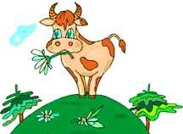f) Afsluitingsvorm van poskaart.

g) Skryf jou naam.

a) The post stamp is written in the right hand corner.

b) The address is written on the right hand side, in the Afrikaans format.

c) The introduction word for the person you are writing to.

d) The person’s name.

e) A short paragraph of 40-50 words about the facts of the topic.

f) Closing word for the postcard.

g) Your name.

**Datum:**

**Kreatiewe werk: Skryf van ‘n poskaart.**

**30 punte**

**OPDRAG**:

Skryf ‘n poskaart vir jou vriend/vriendin waarin jy hulle vertel van jou wonderlike vakansie op oom Jan se plaas. Maak ook ‘n kreatiewe voorkant vir jou poskaart. Die poskaart moet ‘n paragraaf lank wees van 50-60 woorde en moet korrek geadresseer wees. Doen die poskaart in Afrikaans.

(Write a postcard to a friend telling them about your wonderful holiday on Uncle Jan’s farm. Also make a creative front page. The postcard must be a paragraph long between 50-60 words and be addressed correctly. Remember to work in Afrikaans.)

Rubriek :

|  |  |
| --- | --- |
| BESKRYWING VAN ASSESSERING STANDAARDE: | MOONTLIKE PUNTE |
| 1. Die poskaart se adres is korrek neer geskryf. | 0 1 2 3 4 |
| 2. Die poskaart begin met ‘n groetvorm | 0 1 2 |
| 3. Die poskaart bestaan uit een paragraaf | 0 1 |
| 4. Die poskaart het ‘n groetvorm as slot | 0 1 2 |
| 5. Die leerder het by die opdrag gehou | 0 1 |
| 6. Die voorkant van die poskaart is kreatief en kleurvol | 0 1 2 3 4 5 |
| 7. Die leerder se taalstrukture is korrek gebruik | 0 1 2 3 4 5 |
| 8. Die leerder se spelling is deurgaans korrek | 0 1 2 3 4 |
| 9. Die leerder het die regte sinkonstruksies gebruik | 0 1 2 3 4 |
| 10. Die paragraaf is kreatief | 0 1 2 |
| Totaal: | /30 |

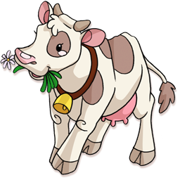

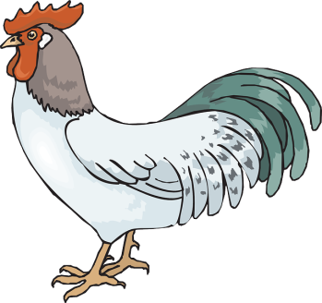

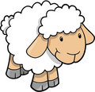

Die voorkant

|  |
| --- |
|  |

Die agterkant:

|  |
| --- |
| \_\_\_\_\_\_\_\_\_\_\_\_\_\_\_\_\_\_\_\_\_\_\_\_\_\_  \_\_\_\_\_\_\_\_\_\_\_\_\_\_\_\_\_\_\_\_\_\_\_\_\_\_  \_\_\_\_\_\_\_\_\_\_\_\_\_\_\_\_\_\_\_\_\_\_\_\_\_\_  \_\_\_\_\_\_\_\_\_\_\_\_\_\_\_\_\_\_\_\_\_\_\_\_\_\_  \_\_\_\_\_\_\_\_\_\_\_\_\_\_\_\_\_\_\_\_\_\_\_\_\_\_ |