Rembrandt Park School
Term 2
Date: ________________________________
Instructional text
Comparing two ways of writing recipes.
READ two ways of preparing pancakes.
Pancake Recipe 1 (makes 10 pancakes)
Ingredients
- 1 cup cake flour 1 teaspoon baking powder a pinch of salt
- ¾ cup milk 1 teaspoon lemon juice 2 eggs
- ½ cup water 100 ml sunflower oil for sprinkling: Sugar and cinnamon
Method
- Sift the dry ingredients together.
- Beat eggs, water and lemon juice together.
- Pour the egg mixture into the flour mixture and mix thoroughly.
- Add the oil and mix until smooth and creamy.
- Leave the mixture to stand for 30 minutes.
- Heat a non- stick frying pan and cook one pancake.
- Sprinkle with sugar and cinnamon then roll up.

Pancake Recipe 2
We’re going to cook up a storm of about 10 lip- smacking, mouth-watering pancakes. In a large bowl, sift together one cup of fresh cake flour, one teaspoon of baking powder and some salt. Now find another bowl and mush two hen eggs, three quarters of cup of milk, 150ml of water and a bit of freshly squeezed or bottled lemon juice. The lemon juice will add a lekker tang to the taste. When this is thoroughly mixed, whack it into the sifted bowl of dry ingredients and mix very well, like a cement mixer would. Now add 100ml of sunflower oil and beat up the mixture until it is smooth like silk. Let it chill for half an hour so that it can settle. On the stove, heat a non-stick frying pan and use a large ladle to scoop up the batter. Cook the pancakes one at a time and flip or turn them carefully. Slap some sugar and cinnamon on, roll’ em up and stuff’ em down while they’re hot.
After you read:
Answer the following question in your book
- List ways in which the recipes differ.
- Layout
- Sentence structure
- Tone
Rembrandt Park School
Term 2
Date: ________________________________
Instructional text
Ordering Jumbled instructions
Baking Cup Cakes
Recipe for FAIRY cupcakes
Ingredients
Cake MixtureIcing
125g softened margarine 50g unsalted butter
1 cup sugar 2 cups icing sugar
3 eggs 2 teaspoons of milk
1 teaspoon of vanilla essence sprinkles to decorate
1 ½ cup of self-raising sugar
¾ cup milk
1 | Remove and allow to cool.
2 | Mix margarine and sugar and then add the eggs and vanilla essence and beat until combined.
3 | Preheat oven to 180 Degrees Celsius. Place cupcake paper into muffin pan.
4 | Fill the cupcake papers with the mixture.
5 | Sift flour into margarine mixture and add milk.
6 | Bake cupcakes for 20- 25 minutes.
7 | Cream the butter until pale and smooth and add icing sugar
8 | Spread the icing onto cakes
9 | Add Sprinkles

The correct order:

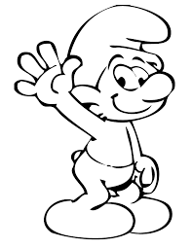
Rembrandt Park School
Term 2
Date: ________________________________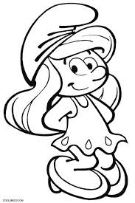
Instructional text
Ordering
The instructions below are for making a cup of tea. They are in the wrong order. Write them in the flow diagram in the correct order.

Put three bags in the teapot. Stir tea in cup with teaspoon.
Leave to brew for five minutes.Put enough milk in a cup. Warm the teapot with hot water. Pour boiling over teabags. Fill a kettle with fresh water. Pour tea from teapot into cup. Boil the water in the kettle.
1.

2.

3.

4.

5.

6.

7.

8.

9.

Rembrandt Park School
Term 2
Date: _______________________________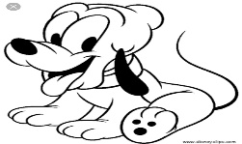
Subject and predicate
Sentences can be divided into a subject and a predicate.
The subject says who or what is doing the action in the sentence.
The predicate is the rest of the sentence and says what is done. It always contains a verb.
Lucyate the chocolate.
To find the subject, first find the verb, then ask who or what did the verb. For example:
Who ate the chocolate? Lucy ate the chocolate.
The predicate can be divided into the verb and object. For example: ate (verb) the chocolate(object).
The object says who or what is being acted upon. To find the object ask who or what after the verb. For example: the women ate what? The chocolate.
Not all predicates contain an object. For example: Stuart (subject) [sang (verb) quietly] - predicate. The word quietly is an adverb which just tells us how Stuart sang. It does not tell us what he sang, so there is no object in this sentence.

- Copy the sentences below into your exercise book. For each sentence:
- Identify and highlight the verb.
- Identify the subject by asking who or what before the verb. Underline the subject.
- Identify the object by asking who or what after the verb. (Put brackets around the object.)

- The tabby cat ate the mouse.
- Most cats enjoy fresh meat.
- Domestic cats eat dried or canned cat food.
- Mice love the cat food industry.
- Write two sentences of your own. The first one must contain an object, the second must not contain an object.

- Choose the correct word in the sentences below. Rewrite the sentences in your book with the correct word.
- The (weather/ whether) forecast predicted rain today.
- She went on a diet hoping to (loose/ lose) some weight.
- Mrs Seema is the school’s (principle/ principal).
- (Its/ It’s) a shame that I cannot attend your party.
- She is going to attend a (course/ coarse) on garden design.

- Form plurals of the following words:
key story pathway lorry nanny artery
Rembrandt Park School
Term 2
Date: ________________________________
Root words, prefixes and suffixes
The main part of a word is called a root word, for example the word unfortunate- fortune is the root word. (it stands on its own)
The prefix comes before the root word. In unfortunate- un is the prefix.
Prefixes can also change the meaning of the word. (fortunate becomes unfortunate) Some prefixes give us a clue to the meaning of the word. (we know that tri means three) Triangle, tricycle, trilogy.
Prefixes often indicate number, for example: uni meaning one, bi meaning two.
The suffix comes after the root. In unfortunate – ate is the suffix. The suffix can also change the meaning, for example: fortune become fortunate.
Suffixes can also change the root word to form nouns, verbs, adjectives and adverbs. For example from the verb satisfy, we can get:
Satisfaction (noun)
Satisfactory (adjective)
Satisfactorily (adverb).

- Add a prefix to the following words to give the antonym.
- Accurate ___________________________
- Complete ___________________________
- Function ____________________________
- Represent____________________________
- Satisfaction___________________________
- Add the correct prefix or suffix to the word in brackets to make the sentence meaningful.
- I enjoyed the chocolate cake I baked, it was(taste). ____________________________________________________________
- If I mix the ingredients many times, I (mix)it. ____________________________________________________________
- When Rob had to stir, he stirred (swift). ____________________________________________________________
- She seemed as if she wasn’t happy with her present, we all thought she was (grateful). ____________________________________________________________
- Minnie seemed angry because of the (understanding) they had with Mickey. _____________________________________________________________
- The bank told her that her car business was (fund). _____________________________________________________________
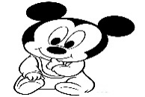
Rembrandt Park School
Term 2
Date: ________________________________
Language activity
Subject and predicate
- Copy these sentences into your book and complete the sentence with a suitable predicate.
- The whole class
- Mrs Smith
- The enormous pizza
- Copy these sentences and underline the object in each sentence.
- The naughty child threw his toy truck out of the window.
- My brother is upstairs.
- The boy kicked the ball.
- I ate the last chocolate.

Verbs
- Rewrite these sentences and underline all the verbs. (some sentences contain more than one verb)
- The wind blew ferociously and uprooted many trees.
- The bacon sizzled in the pan.
- It was his eighth birthday yesterday
- I love school and miss my friends during the holidays.
Prefix and suffix
- Find three words that begin with the prefix circim- write them down and explain what each word means.
- The root word port means carry. Add three different prefixes to this root word and give definitions for your new words.
- Add suffixes to the words below to change them into verbs.
Idol length spark sermon
- Rewrite the following and correct the punctuation.
- Are you a king asked the boy.
- The mens ties were identical.
- Its time for Sunday lunch.
- That book is yours.
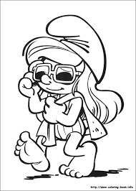
Rembrandt Park School
Term 2
Date: ________________________________
Novels
A book tells us a story about people and things that are not real. Some books are true if they are called documentary books.
A BLURB is a short review written on the back cover of a book. A blurb will help you in deciding whether you want to read the book or not, if the blurb is interesting it is then assumed that the book may also be as interesting.
Before you read
- a) Look at the cover of this book: What do you think this book is about?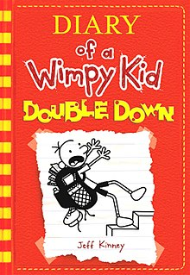Would you like to read it? Why?

Read a blurbThe text below is called the blurb. It is written on the back cover of a book and tells people what the book is about.
The pressure’s really pilling up on GregHeffley. His mom thinks video games are turning his brain to mush, so she wants her son to put down the controller and explore his “creative side.”
As if that’s not scary enough, Halloween is around the corner and the frights are coming at Greg from every angle.When he discovers a bag of gummy worms, it sparks an idea. Can Greg get his mom off his back by making a movie… and will he become rich and famous in the process? Or will doubling down on this plan just double down Greg’s problems?
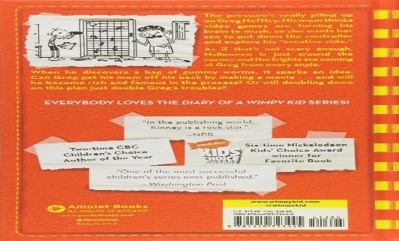
Rembrandt Park School
Term 2
Date: ________________________________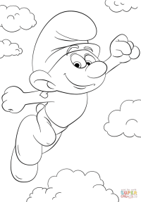
Novels
Characters
The characters are very important in a novel. If we do not find them interesting and convincing, we will not care about what happens to them

Setting
Setting is where and when the different scenes of a novel take place. It is important for the writer to create a vivid sense of these scenes.

Plot
The plot is what happens. A good novel needs a good plot, but the writer must also manage the plot to keep the suspense. Each chapter should end in a way that makes you want to read on. A twist, or surprise, can make a plot more interesting.

Rembrandt Park School
Term 2
Date: ________________________________
Finite and infinitive forms of the verb
The finite, or main form of the verbhas a subject, a tense and can be singular or plural. For example :
Mum says hello.
Stella was in the water.
Infinitive verbs are the base form of the verb, for example go, and to go. Infinitive verbs have no tense, number or subject.

- Underline the main verbs( finite) and circle the infinitive verbs
- The family decided to sail around the world in a ship.
- Last summer, Smuffet learnt how to sail.
- Begin the following sentences with to and the infinitive verb. The first one has been done for you.
- It takes a lot of courage to sail around the world. To sail around the world takes a lot of courage.
- He climbed to the top of the hill to get a better view of the island. ________________________________________________________________________________________________________________
- It takes strength, training and skill to become a good sailor. _______________________________________________________________________________________________________________
- Some young South Africans have joined Smurfnet to learn how to sail. ________________________________________________________________________________________________________________

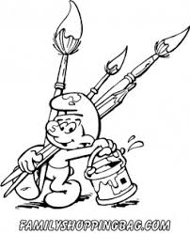

Rembrandt Park School
Term 2
Date:_______________________________
Writes an instructional text
- Carefully read the text below on How to make a sandwich.
- Complete the recipe below.
Lebo takes 2 slices of bread. She passes them to her brother Zola. He smears chocolate spread on one side. Meanwhile, Lebo uses a knife to cut 4 marshmallows into thin slices. Her brother places the marshmallows on top of one slice. Lebo adds 6 sour worms and 1 teaspoon of sprinkles onto the marshmallows. Finally Zola places the other slice on top of the sour worms and sprinkles. She places the sandwich on a plate and serves her mother.
Title
A recipe for ______________________________________________________
Ingredients utensils
_______________________________ ______________
_______________________________ ______________
_______________________________
_______________________________
_______________________________
Method (remember to use imperative verbs to start each instruction)
- ______________________________________________________________________________________________________________________
- ______________________________________________________________________________________________________________________
- ______________________________________________________________________________________________________________________
- ______________________________________________________________________________________________________________________
- ______________________________________________________________________________________________________________________
- ______________________________________________________________________________________________________________________
- ______________________________________________________________________________________________________________________
- ______________________________________________________________________________________________________________________
Rembrandt Park School
Term 2
Date: ________________________________
Statements , commands and questions.
- A statement is a way of saying something so that it appears true.
We have English every day.
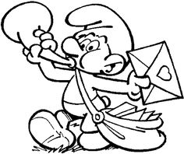
- A command is a way of telling someone something to do
Sit down. Stop talking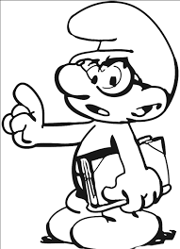

- Many questions start with the words: who, why, when, what and where( interrogatives)
Questions ALWAYS end with a question mark. (?)
Why do we get so much homework? 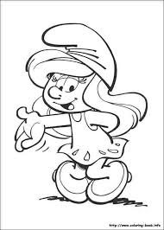
In your books create ninesentences. Three sentences, three commands and three questions.
Rembrandt Park School
Term 2
Date: ________________________________
The continuous ( progressive) tenses
The verbs in the continuous tense continue the actions. They go on for a while.
Dad was making tea while Michealwas doing an investigation.
You can use the continuous tense in the present, past and future. You use this tense in different ways:
For an action that began in the past and is still continuing, for example: I am reading a fantastic novel.
For an action going on when another action took place, for example: I was reading when she arrived. While I was reading she arrived.
For an action going on a particular time, for example; At 9 o’clock, I was reading.
For an action in the future, for example:
Tomorrow morning I am seeing the doctor. Or: Tomorrow morning I am going to see the doctor.

- Underline the continuous verbs in each sentence, then say whether each one refers to the past, present or future continuous tense.
- While Michael was steering, mum was asleep. ________________________________________________________
- What are you reading? ________________________________________________________
- When will you be coming home? ________________________________________________________
- She couldn’t believe that I was driving. ________________________________________________________
- She wanted to know if you are capable of thinking. ________________________________________________________
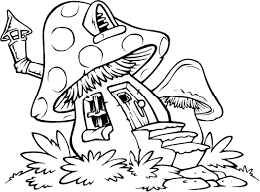
Rembrandt Park School
Term 2
Date: ________________________________
Idioms
Idioms are examples of figurative language. This is creative language that does not mean exactly what it says. Eg“ be all ears” means be eager to hear what someone else has to say.
Match the idiom with the correct meaning by coloring the boxes in the same color.
 | IDIOM | MEANING
1 | In a pickle. | A totally useless possession that you’d like to get rid of.
2 | Butterflies in the stomach. | Pretend that danger doesn’t exists when it really does.
3 | Open a can of worms. | A weird feeling caused by fear or nervousness.
4 | White elephant. | Going through the mind without you even taking note of it.
5 | Bury your head in the sand. | Stay calm
6 | Don’t count your chickens before they hatch. | You are in trouble.
7 | To put your foot into your mouth. | You ask for a lot of food, but then you cannot eat it all.
8 | To beat around the bush. | To avoid coming to the point.
9 | In one ear and out on the other. | Information gotten from the most reliable source.
10 | Keep your shirt on. | To say something you shouldn’t have said.
11 | Your eyes are bigger than your stomach. | Make-believe sorrow.
12 | Straight from the horse’s mouth. | Start a lot of trouble that will be hard to stop.
13 | A close shave. | To be grumpy.
14 | Crocodile tears. | A narrow escape from danger.
15 | To get up on the wrong side of bed | Don’t make plans based upon something that hasn’t happened yet.

Rembrandt Park School
Term 2
Date: ________________________________
Auxiliary verbs
Many verbs are made up of two words , not just one
For example: I am writing a story.
We shall be running in the race.
The verbs – writing and running are helped by special verbs called auxiliary verbs. The main auxiliary verbs are:
To be, to have and to do.
Auxiliary verbs help to form the tense of the sentence for example:
I was writing a story
We are running in the race.
Other auxiliary verbs are:
Shall, will, must, could, should, may, can, might and would.

- Fill in the missing auxiliary verbs.
- We ___________________ going to play a trick on you.
- The dog _______________ been barking all day.
- They __________________ be late if they don’t hurry up.
- Anansi _________________ talking to tiger in the forest.
- I ______________ not do as you say.
- Anansi __________ noticed that the rock was magic.
- They _________ surprised to see snake tied to a pole.
- King K _________ banish all the thieves.
- Sumrfs_________ talking in church.
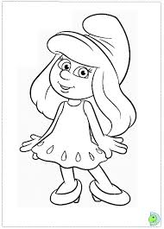
Rembrandt Park School
Term 2
Date: ________________________________
The present perfect tense
The present perfect tense is used to talk about an action that happened some time in the past, but has importance in the present.
For example: I have read that fable many times
It is formed by putting have or has in front of the past participle.
The past participle usually ends in – ed, d, t or en. For example : Moved, heard, learnt, taken or chosen.
We never use the present perfect tense with very specific time expressions like yesterday, a year ago, last week, when I was a child, one day. For example: I have reat that fable yesterday (incorrect)
I read that fable yesterday. (correct)

- Complete these sentences in the present perfect tense. You will have to change the verb in the brackets.
- The train to Durban___________ already (leave)
- Alan ________________ (be) to the Kruger National Park twice.
- Great news! My dog ___________ (have) puppies.
- I ___________ (break) my leg once.
- We __________(live) here for a long time.
- I _________(speak) to him everyday.
- Jack always __________(sing) in the choir competition.
- We __________(speak) to the mother.
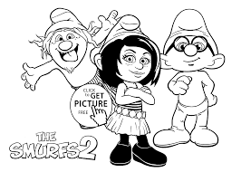

Rembrandt Park School
Term 2
Date: ________________________________
Adding- ing to the main verb.
Adding ing to the main verb have 4 rules, the rules are as follows.
Rule 1.
Verbs that end in –e :
You drop the –e then add ing.
Live – Living
Come – Coming
Rule 2
Verbs that have the consonant vowel consonant form:
You double the last consonant then add ing.
Sit – Sitting
Put – Putting.
Rule 3
Verbs that end with L after a vowel:
You double the L
Travel – Travelling
Cancel – Cancelling
Rule 4
Verbs that end in –ie :
You drop the e and change the i to y .
Rewrite the following sentences into your books. Choose either the simple past or past continuous form of the verb in the brackets to complete the sentences.
- What ______ Micheal ______(do) when Stella (come)_______ up on deck?
- While Mum _________ at the wheel, Dad ____ ______ (make) tea.
- Micheal ____(notice) that Stella ____ _____ _____ (not wear) her harness.

Rembrandt Park School
Term 2
Date: ________________________________
How to write your own fable
Step 1
- Decide what moral or lesson you want your fable to teach. Look at your idiom worksheet to give you an idea.
Step 2
Write a rough draft (first draft) using the following frames:
- Beginning – choose a setting and decide which characters to use.
- Middle –Choose a weakness for your main character. Link the weakness to their stereotypical character. eg a lion is always proud.
The conflict should lead to a big event or climax.
- Ending – the character learns the lesson of the fable.
Step 3 : use the following checklist to help edit your story.
- Is the fable short?
- Does it have animal characteristics?
- Does one character have a weakness?
- Does this weakness create conflict in the story ?
- Is there a big event or climax in the story?
- Does the climax lead to the character learning the lesson?
- Is the lesson or message clearly expressed at the end?
Step 4
Write your edited story neatly.
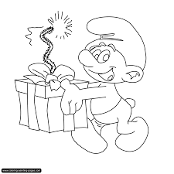
Rembrandt Park School
Term 2
Date: ________________________________
Simple past tense
Simple past tense is used to express an idea that started and finished in the past. For example;
I saw a movie yesterday.
It is used to describe something that you used to do.
I played soccer when I was six.
It is also used to describe facts or generalisations.
He did not like broccoli before.
It is also used to describe a series of completed actions in the past.
I finished my homework and read a book.

- Rewrite these sentences, changing the verbs in brackets to the simple past tense.
- It (be) great.
- I (travel) around by car and (visit) different places.
- We (be) very lucky with the weather.
________________________________________________________________________________________________________________________________________________________________________________________________________________________________________________________________
Attributive adjectives
Attributives adjectives are adjectives that come beforethe noun they describe. For example:
Fierce dog
Grumpy old man
Sweet young girl

- Rewrite these sentences with the adjectives in the correct places.
- The weather set in (cold).
- The wind blew and the rain came down (strong/ heavy).
- The TV news predicted a breeze along the coast (gentle).
- Meteorology involves predicting the weather (different).

